Start Lab – Aws icon ( yellow to green )

**Task 1. Create an S3 bucket using the AWS CLI**

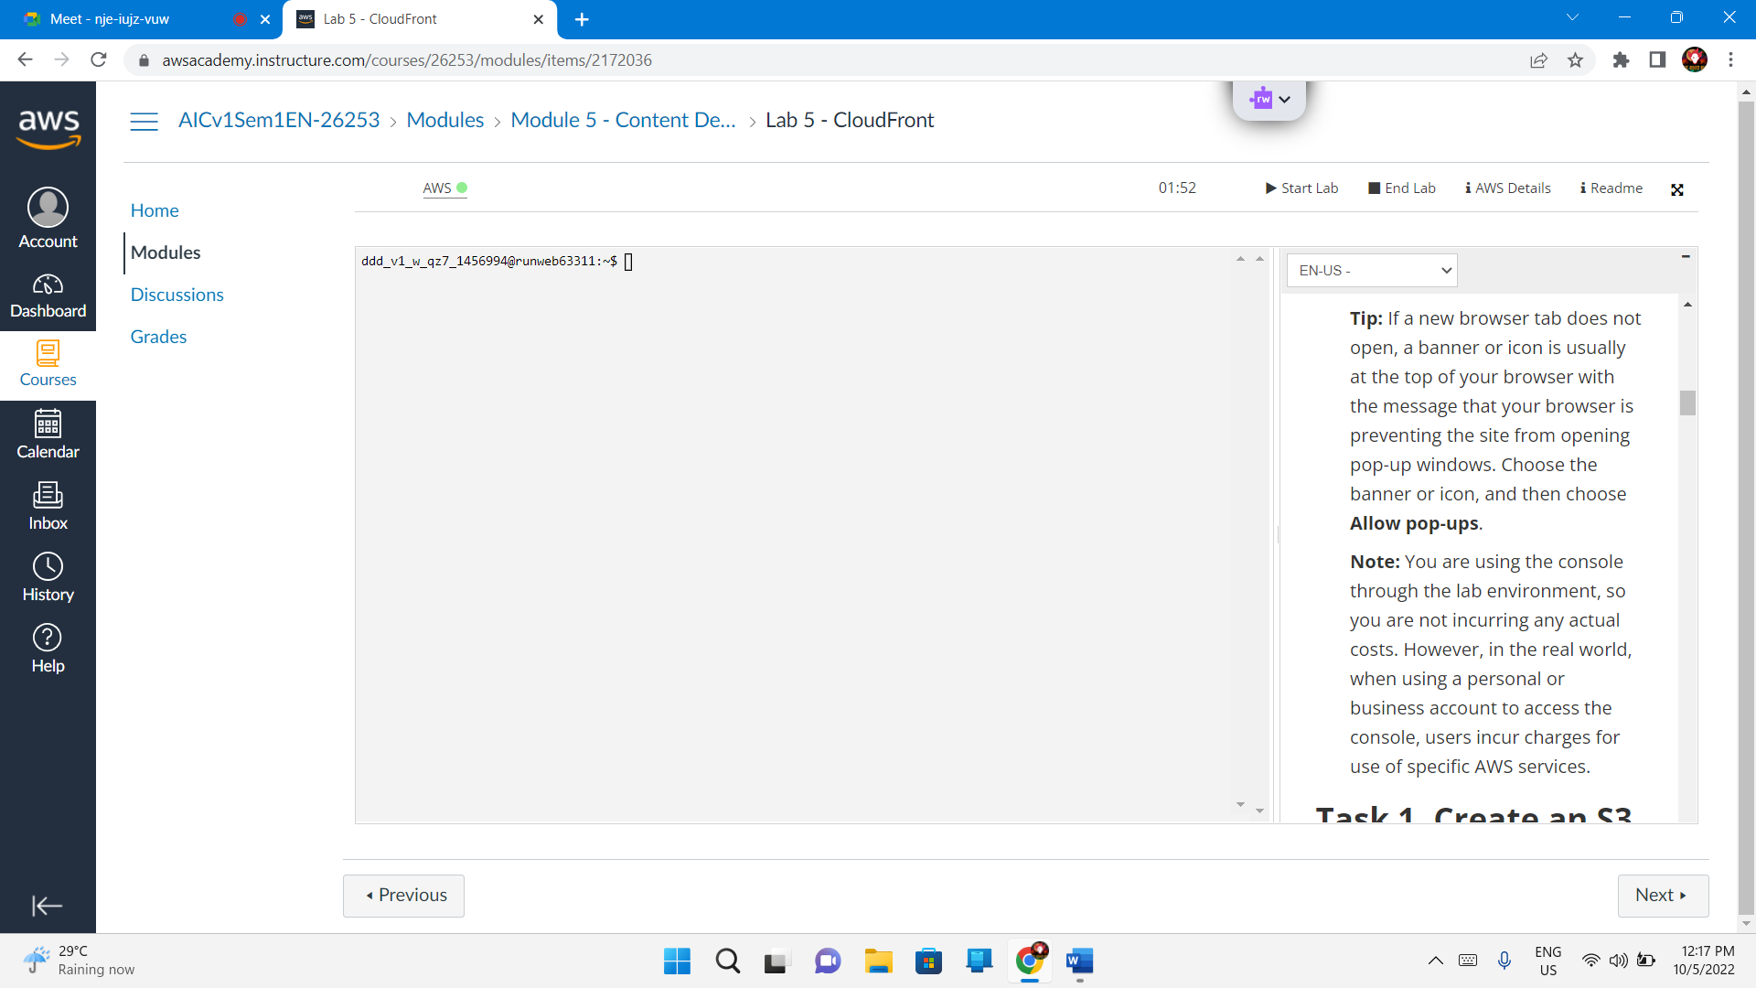

Services – Developer tools – CloudFront

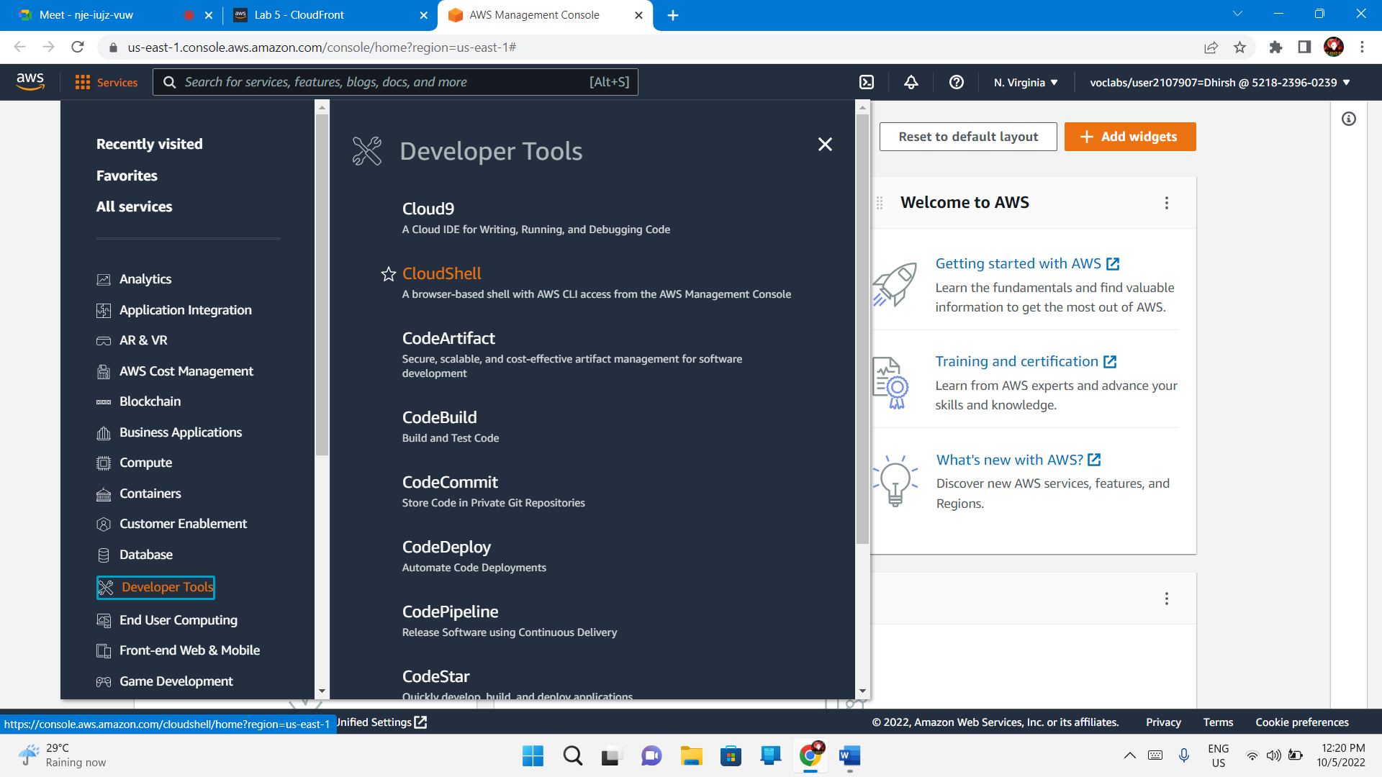

Close

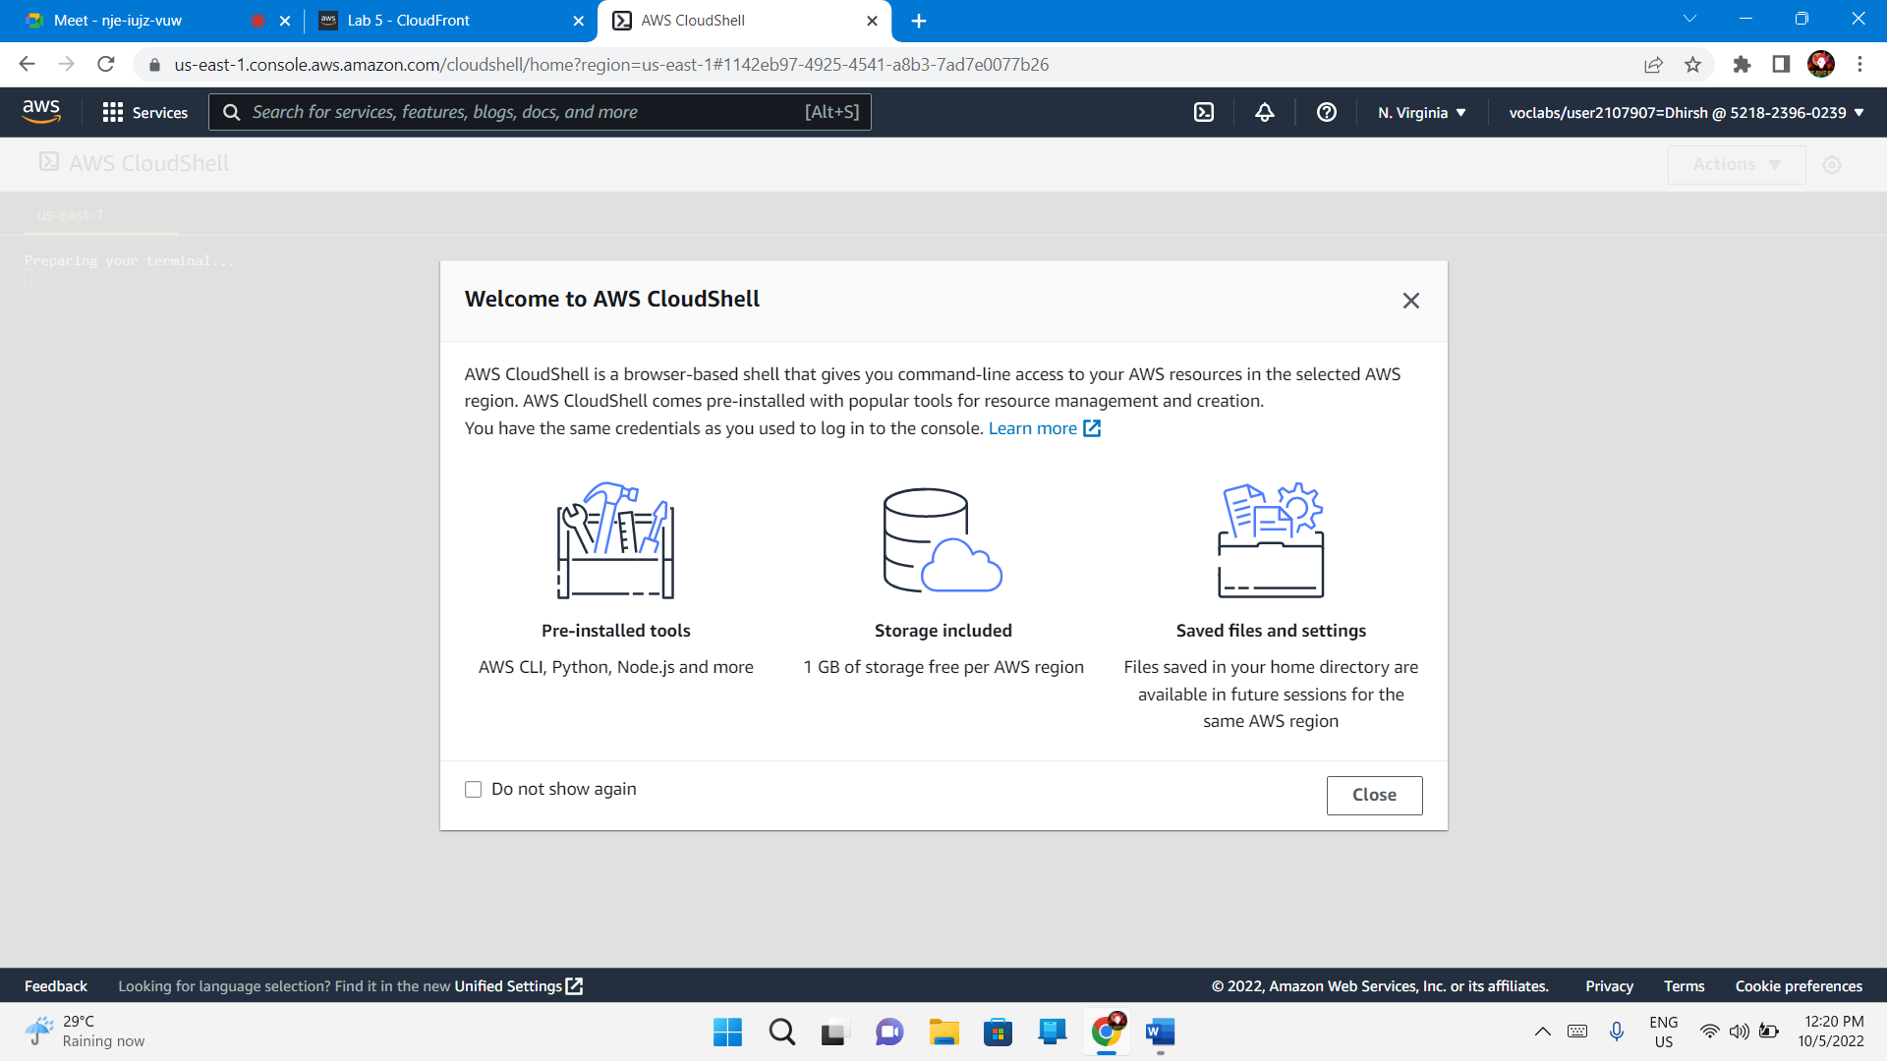

Copy paste the code in the editor

cd ~

aws s3api create-bucket --bucket (bucket-name) --region us-east-1

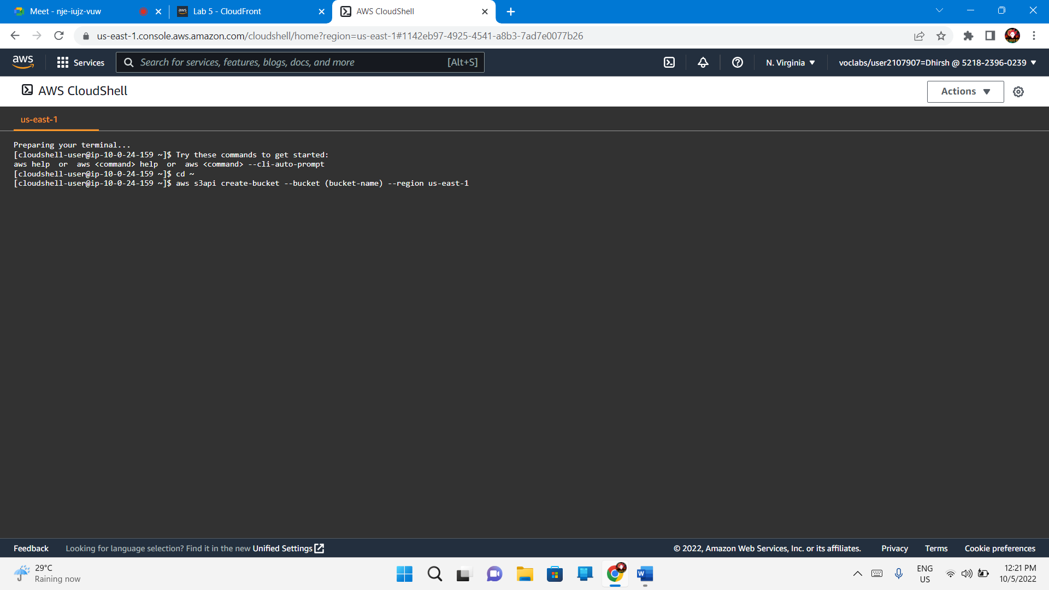

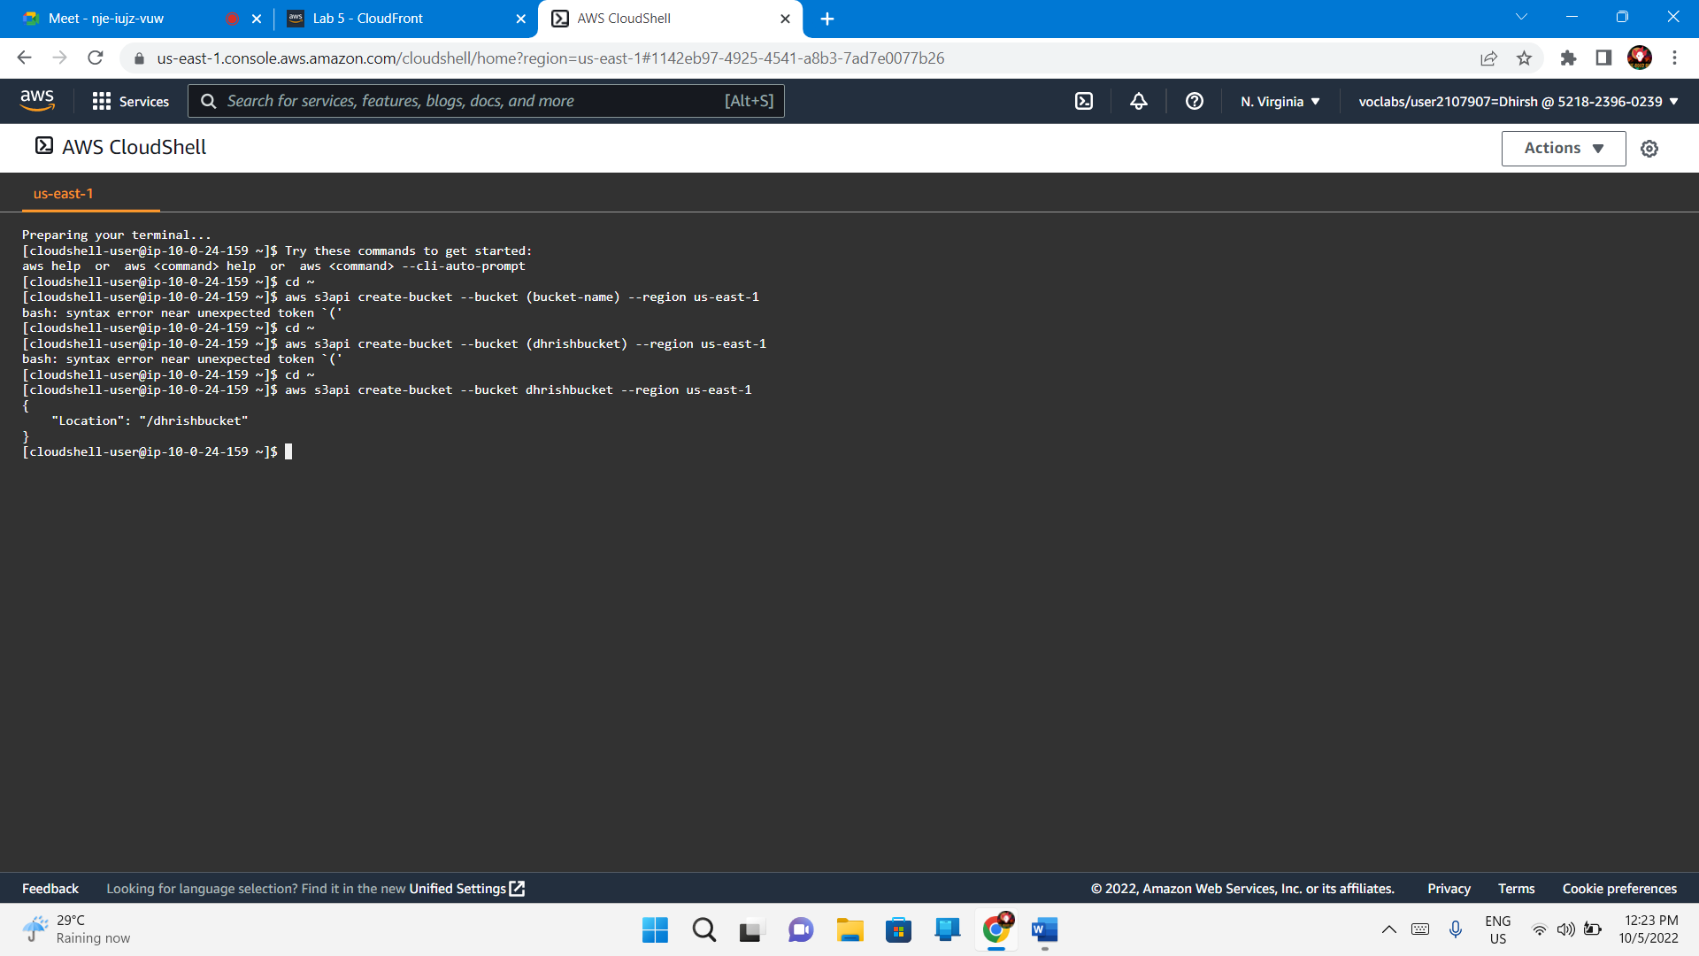

{

"Location": "/dhrishbucket"

}

[cloudshell-user@ip-10-0-24-159 ~]$

## Task 2. Add a bucket policy

Service – Storage – S3

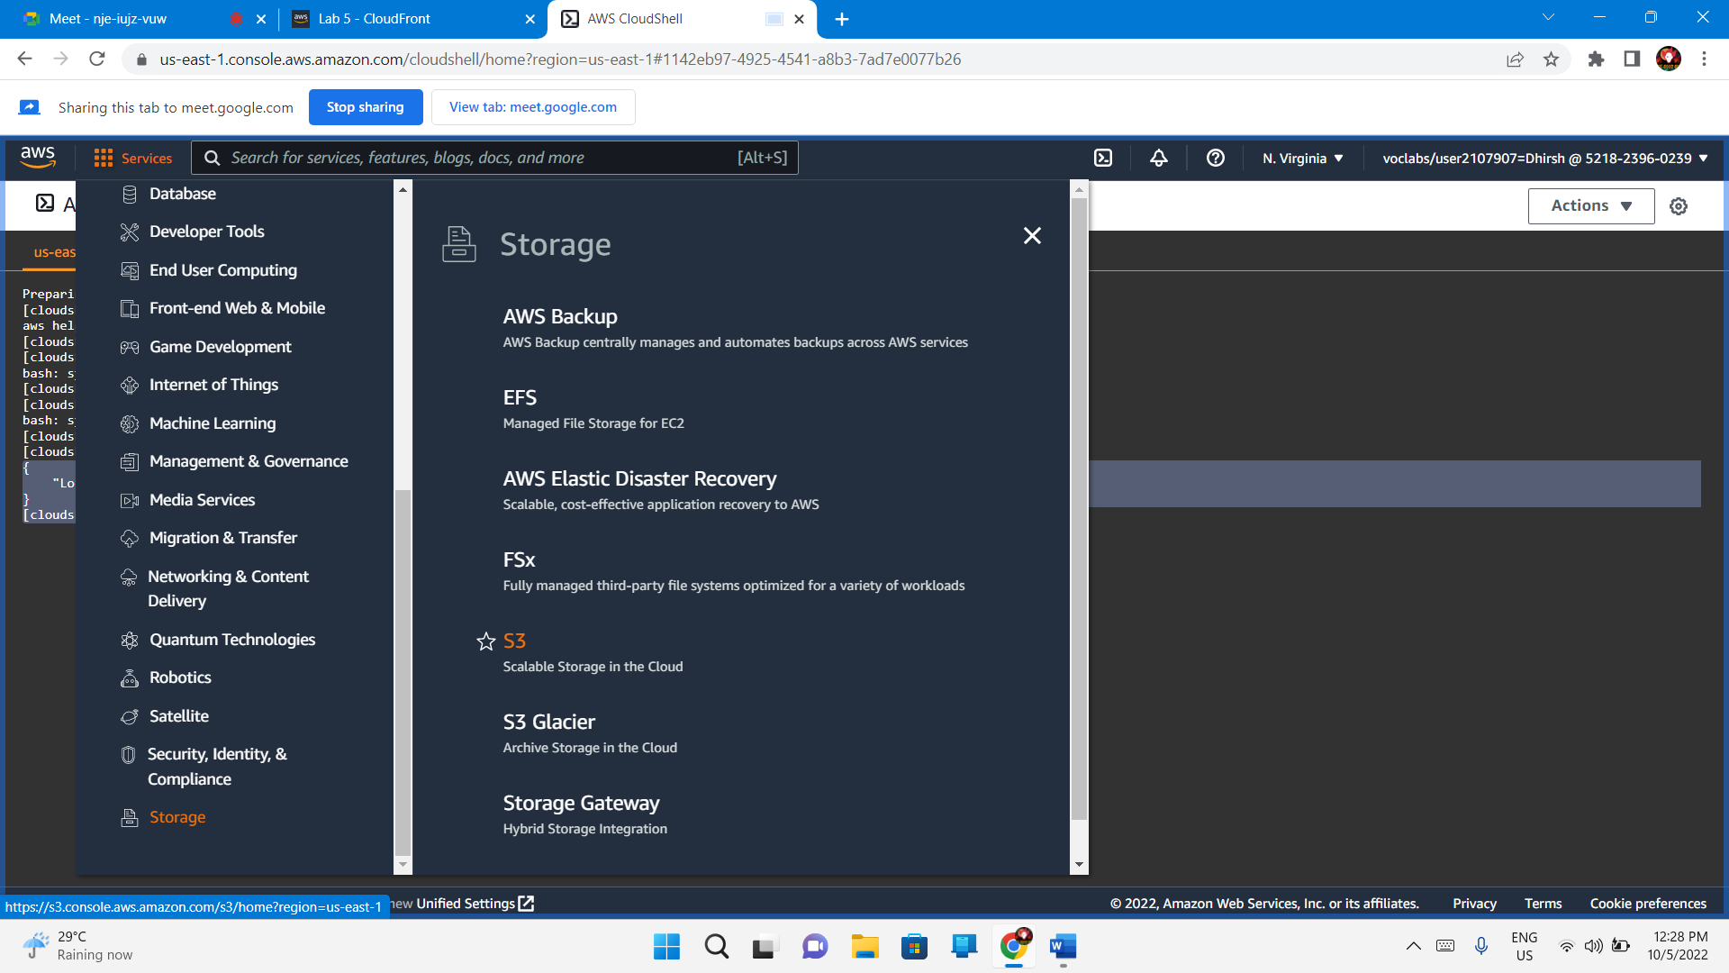

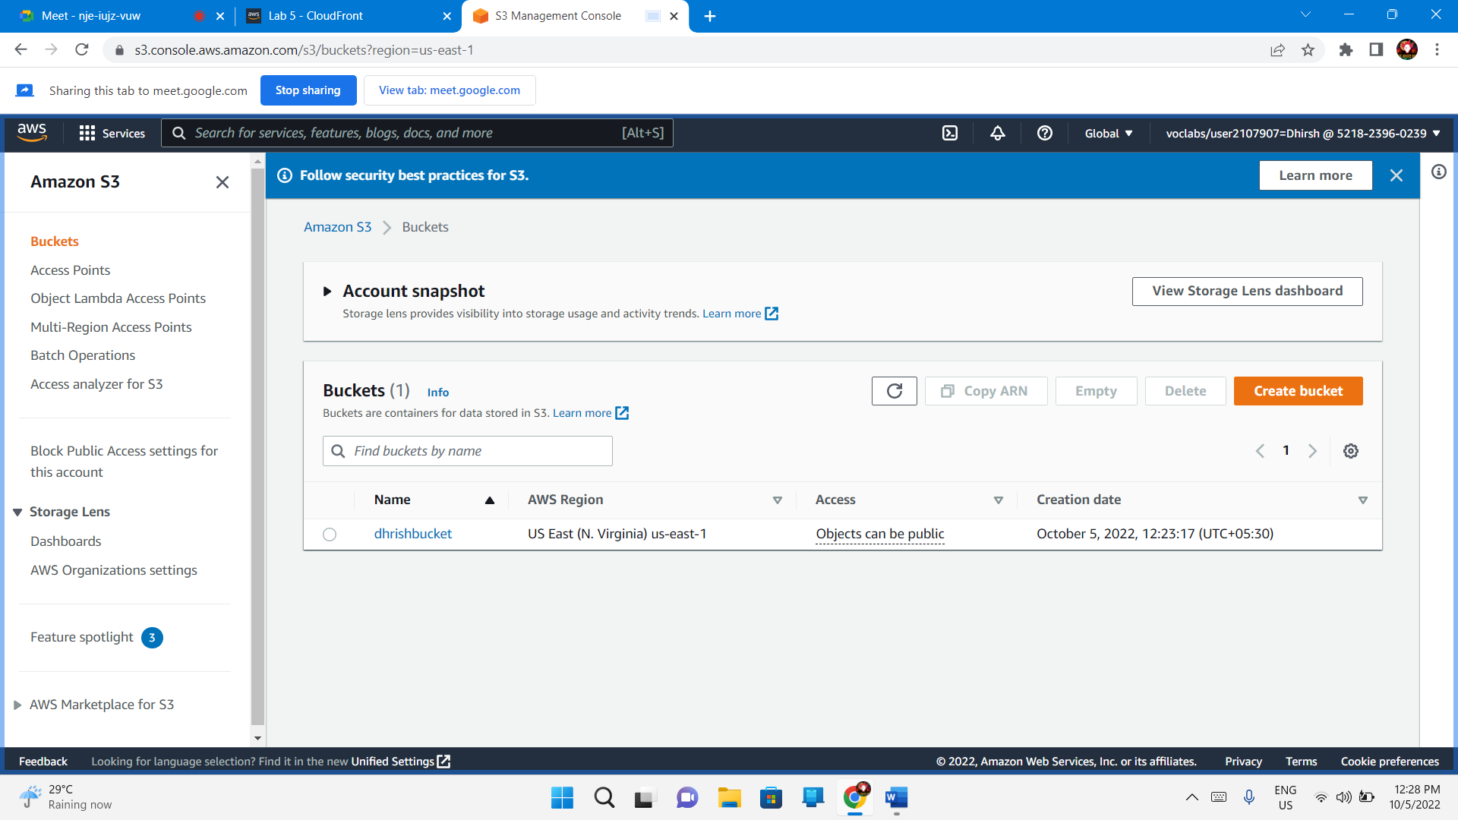dhrishbucket – Permissions -Edit

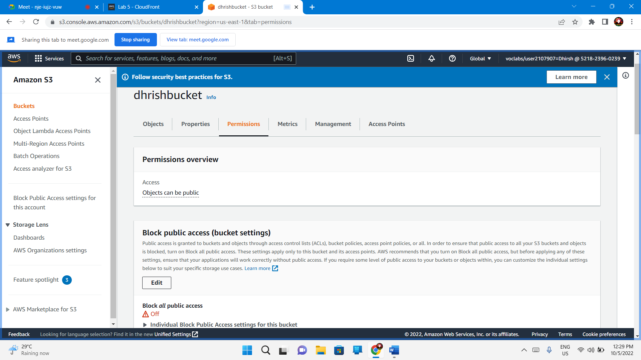

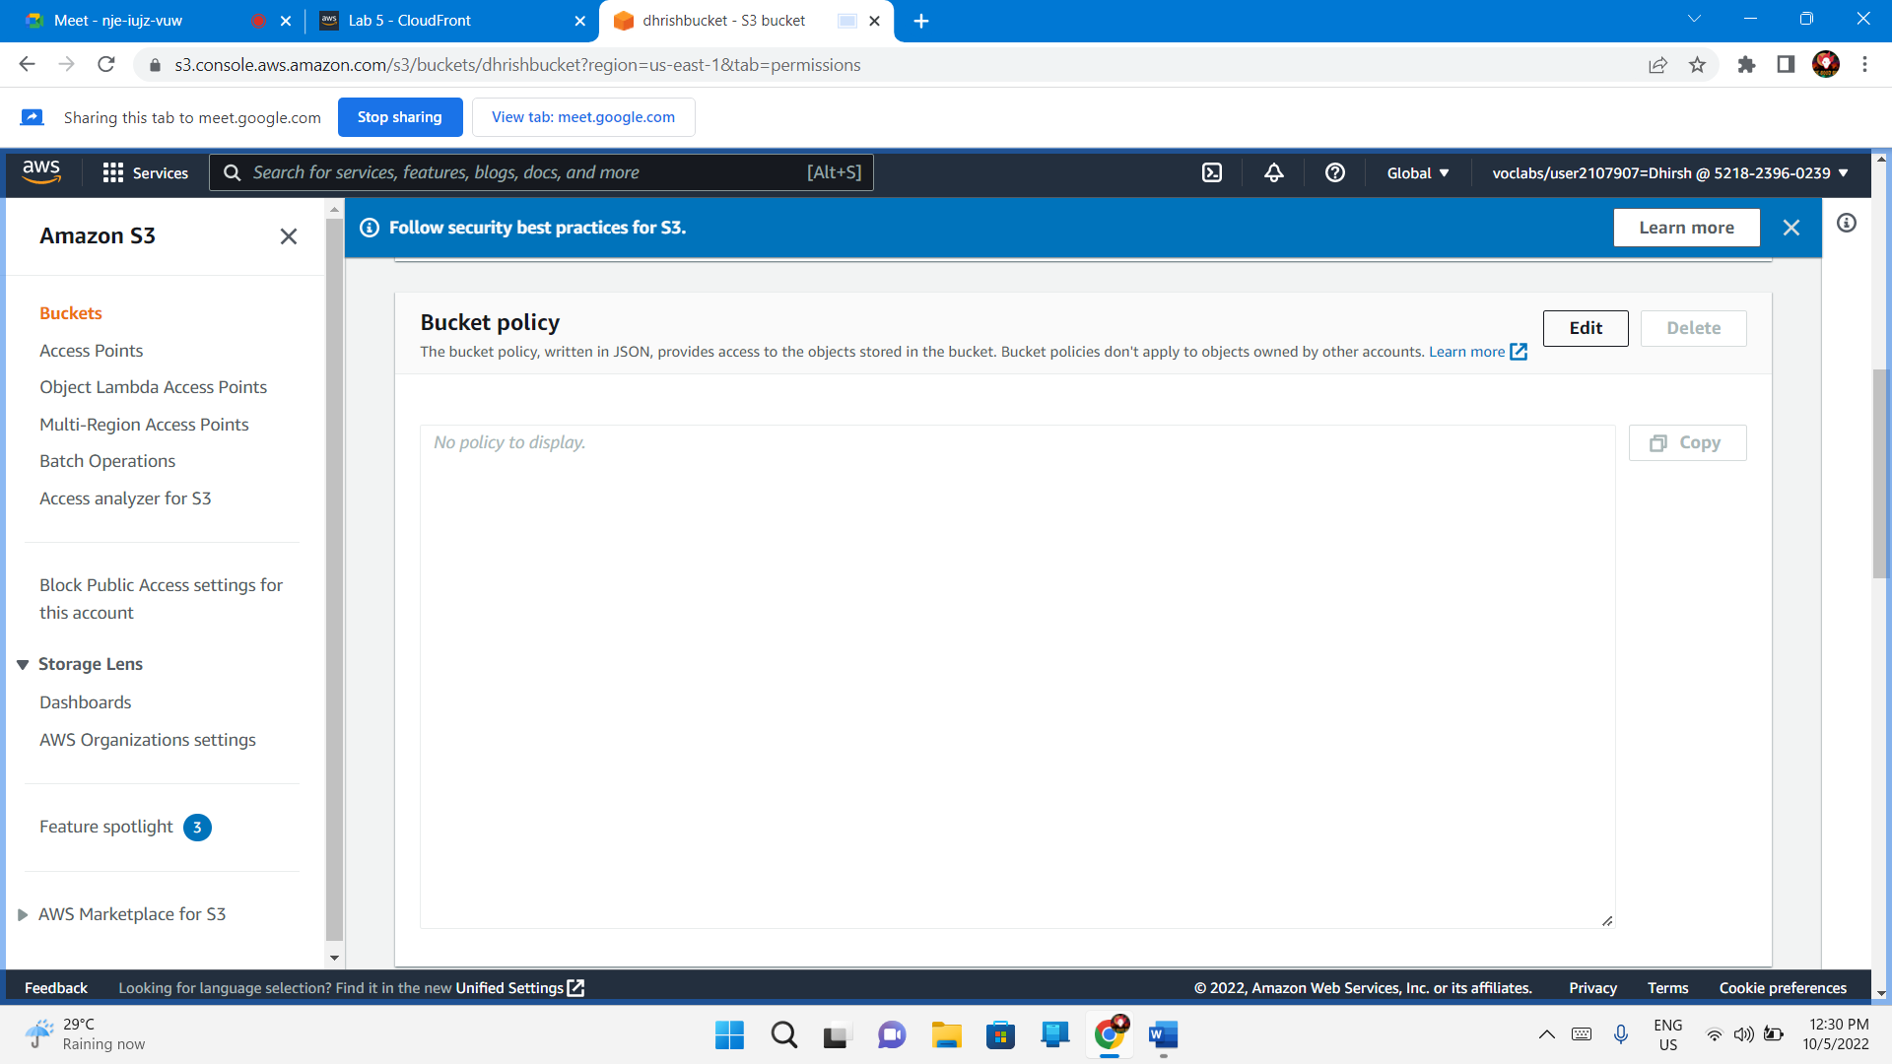

{

  "Version":"2012-10-17",

  "Statement":[

    {

        "Sid":"PublicReadForGetBucketObjects",

        "Effect":"Allow",

        "Principal":"*",

        "Action":[

           "s3:GetObject"

        ],

        "Resource":[

           "arn:aws:s3:::dhrishbucket/*"

        ]

    }

  ]

}

Save Changes

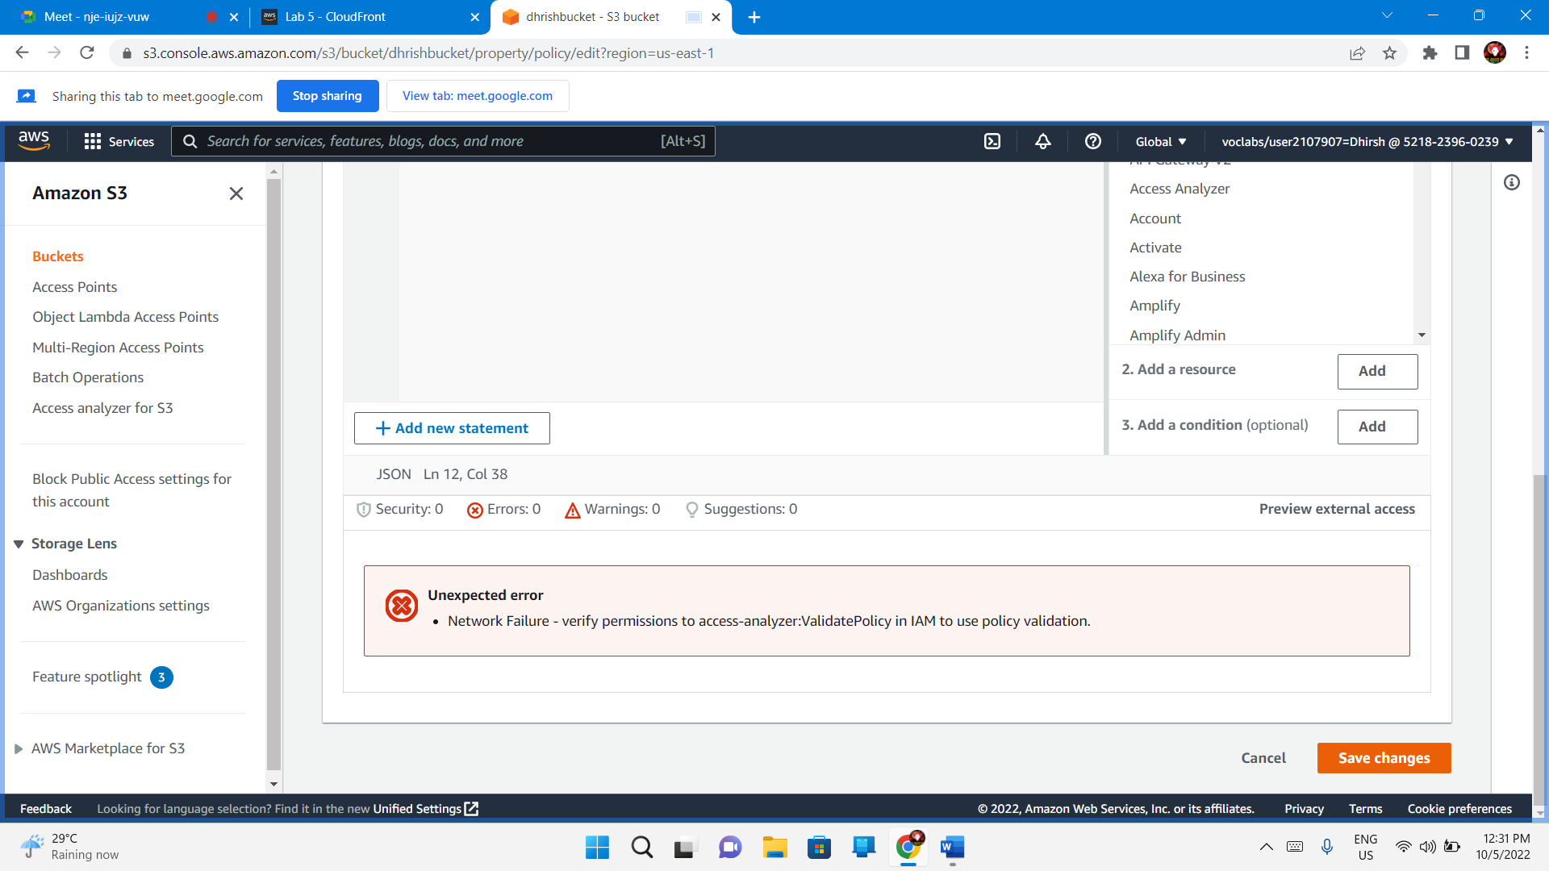

## Task 3. Upload an HTML document

Save the index.html file to your local computer.

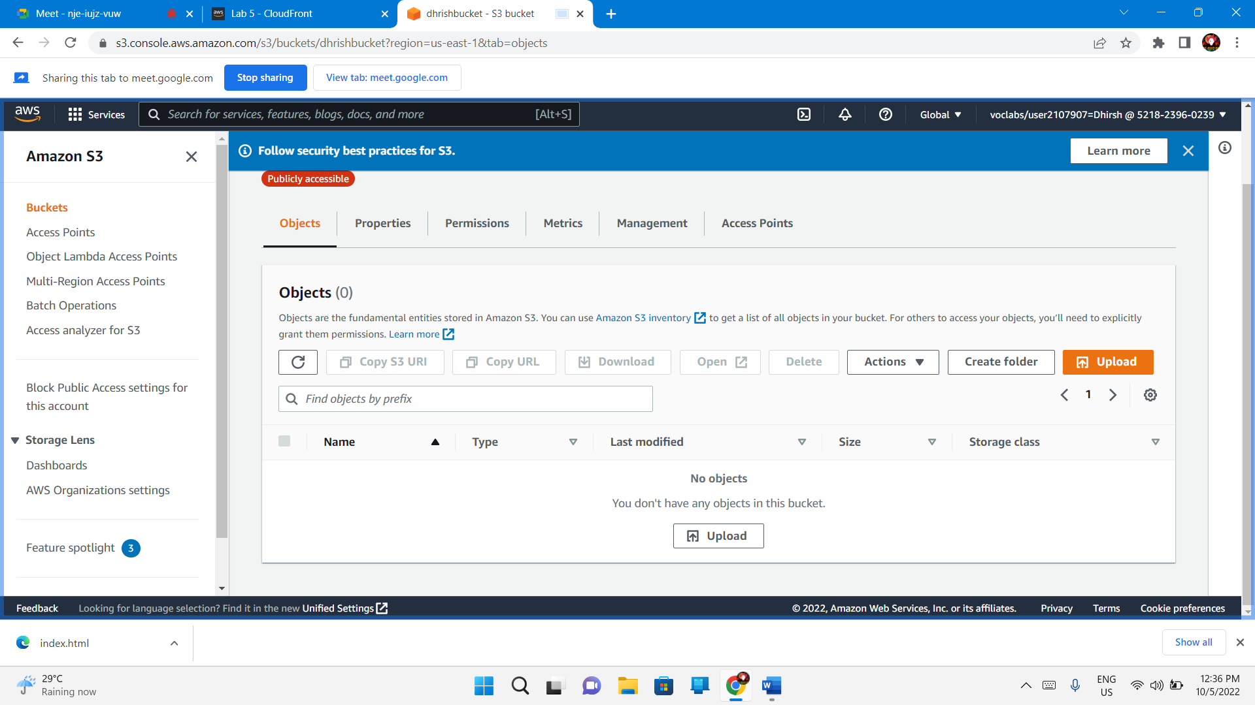Objects – Upload

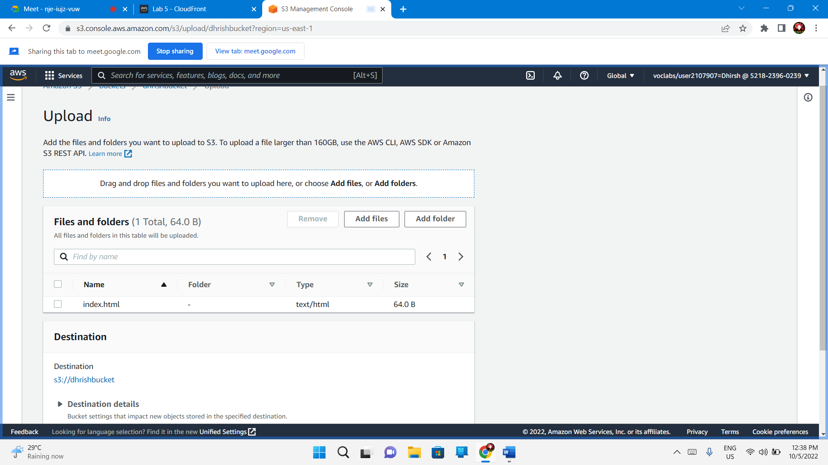

Permissions - Grant public-read access

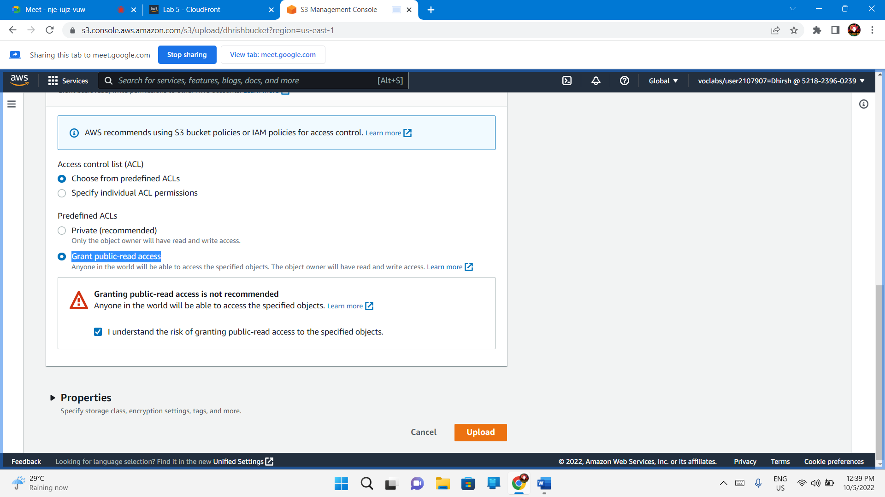

Upload

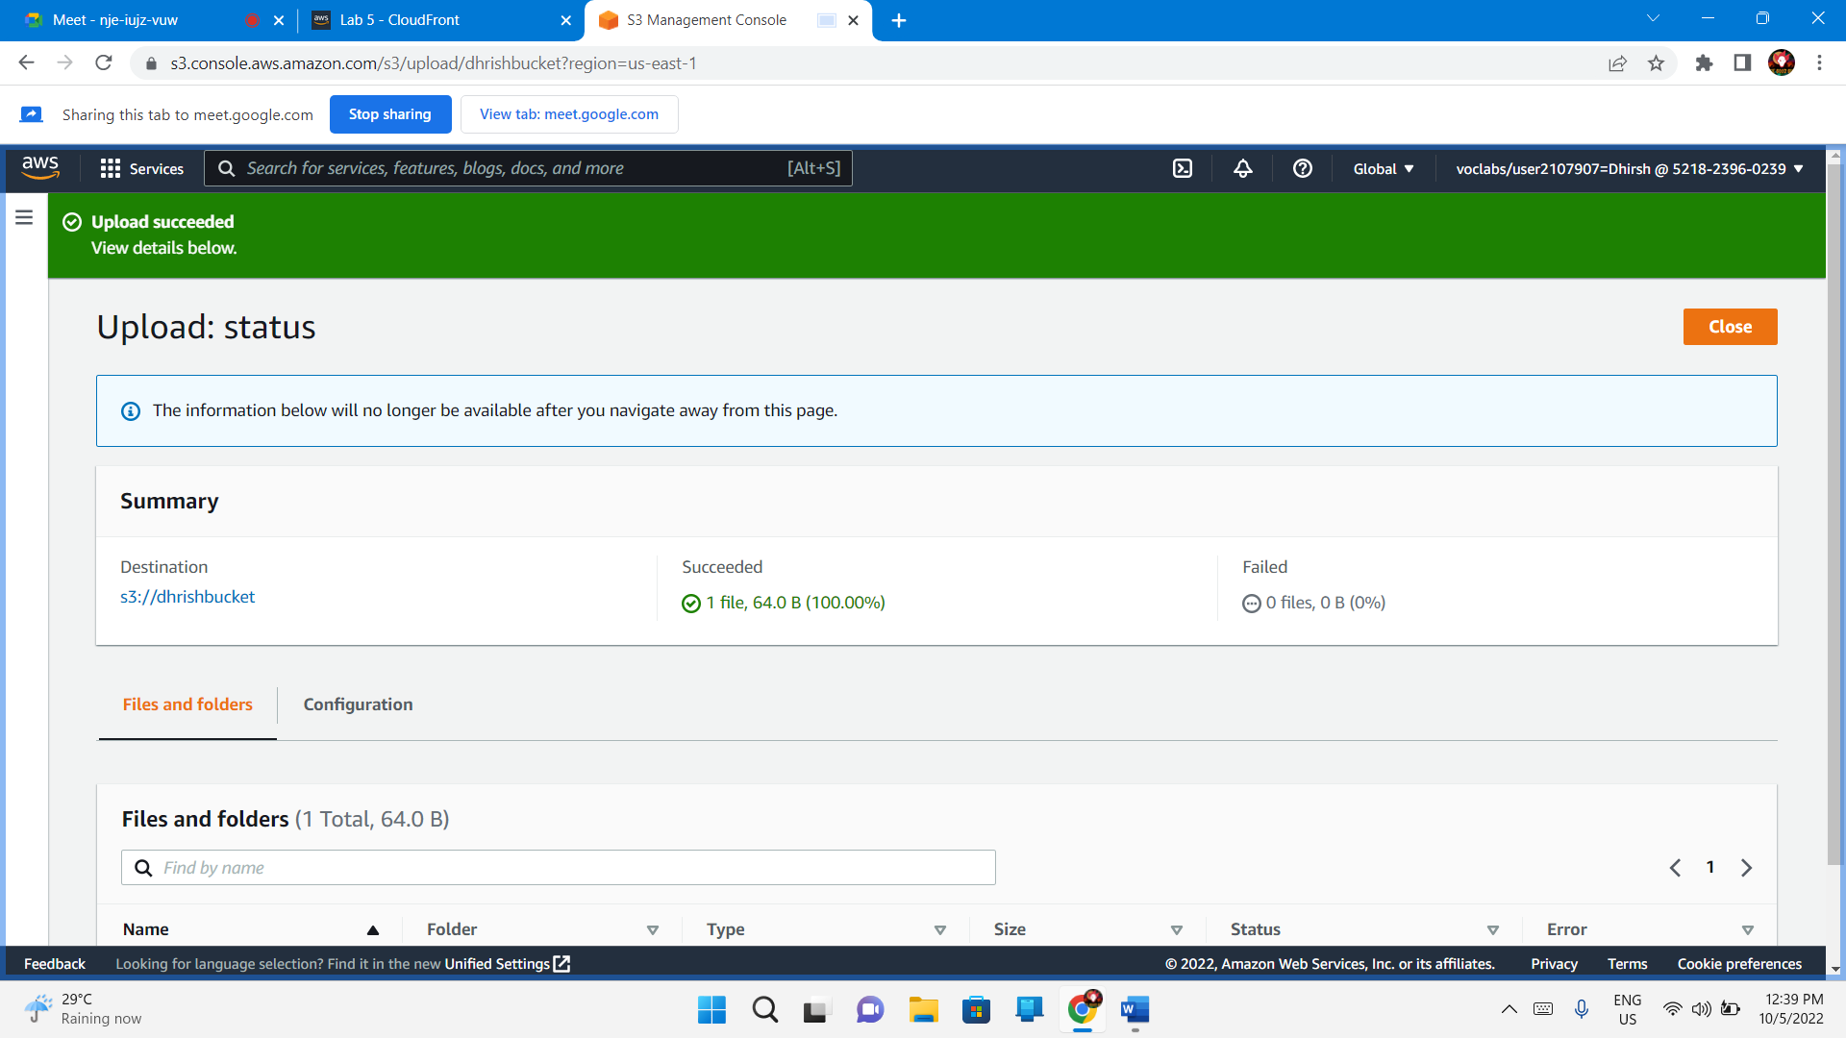

## Task 4. Test your website

Index.html – Properties

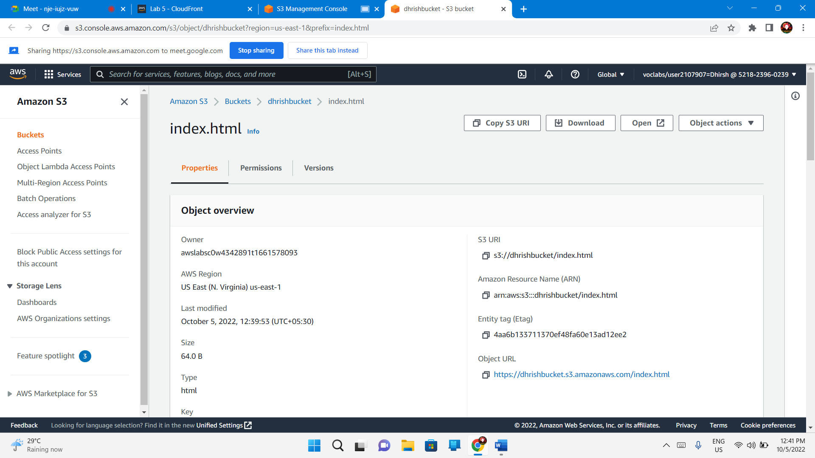

Properties – Enable – Static Web Hosting

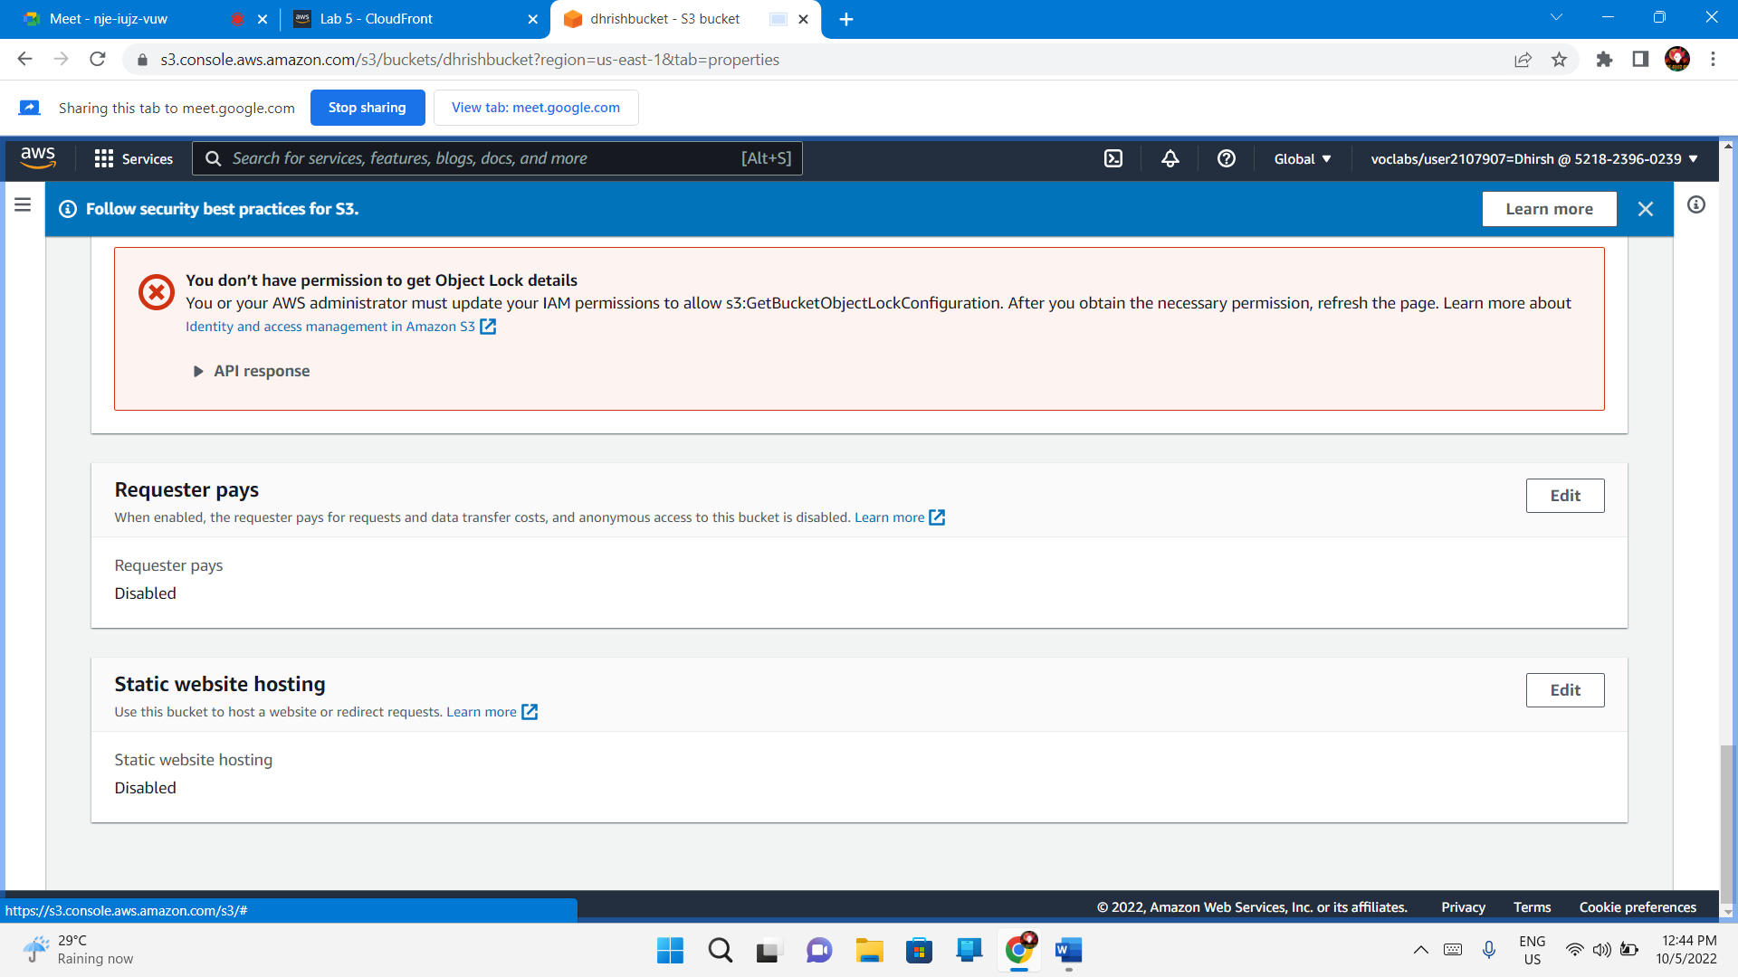

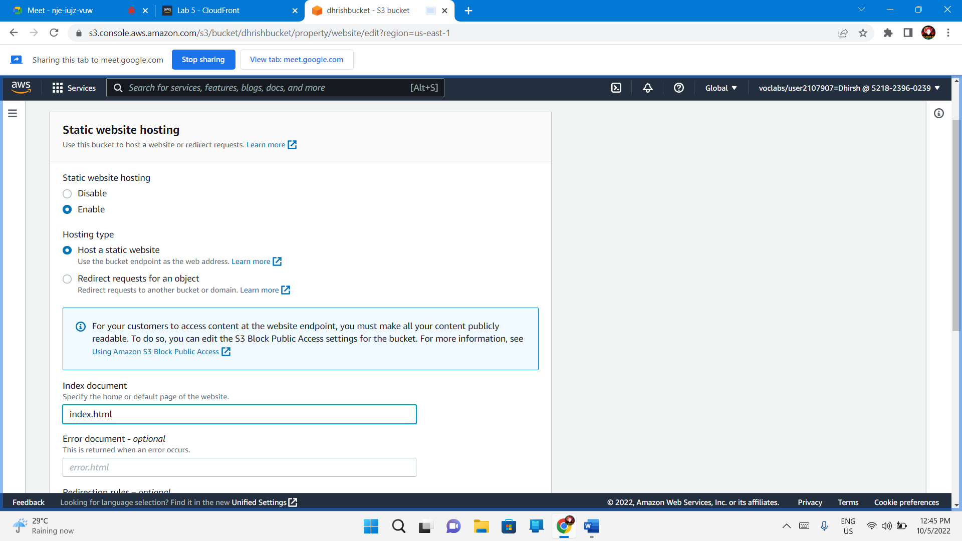

Save changes

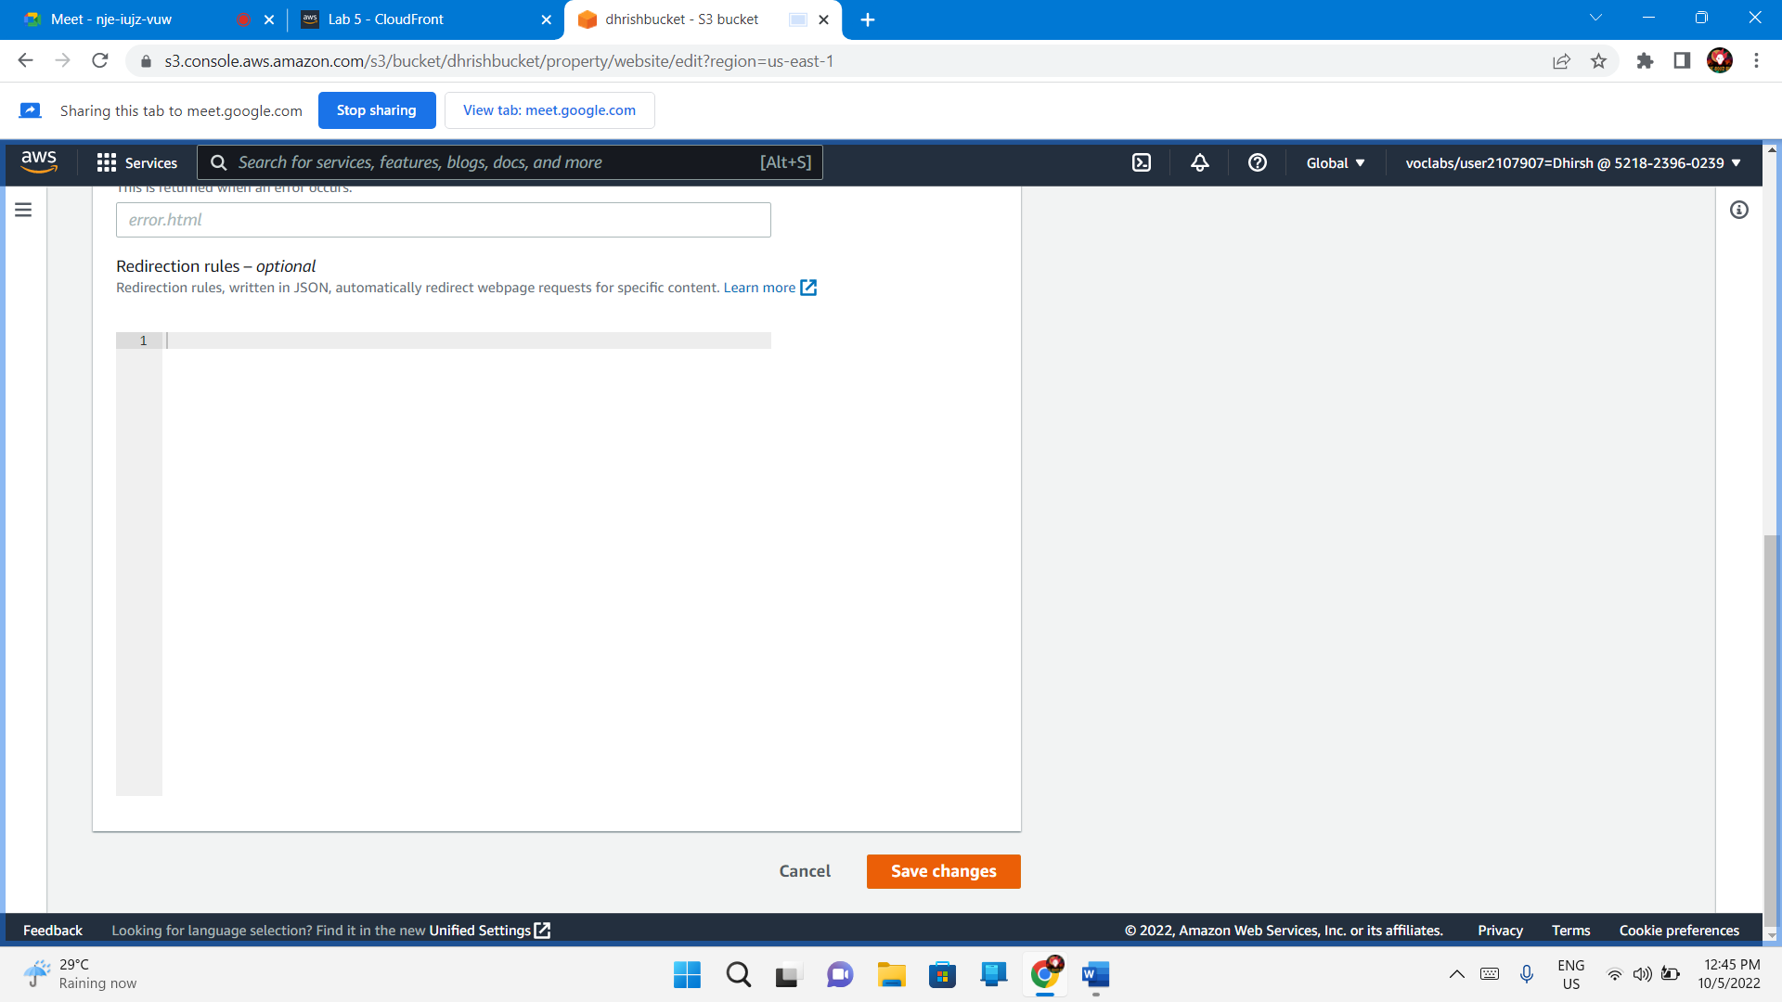

Copy the endpoints

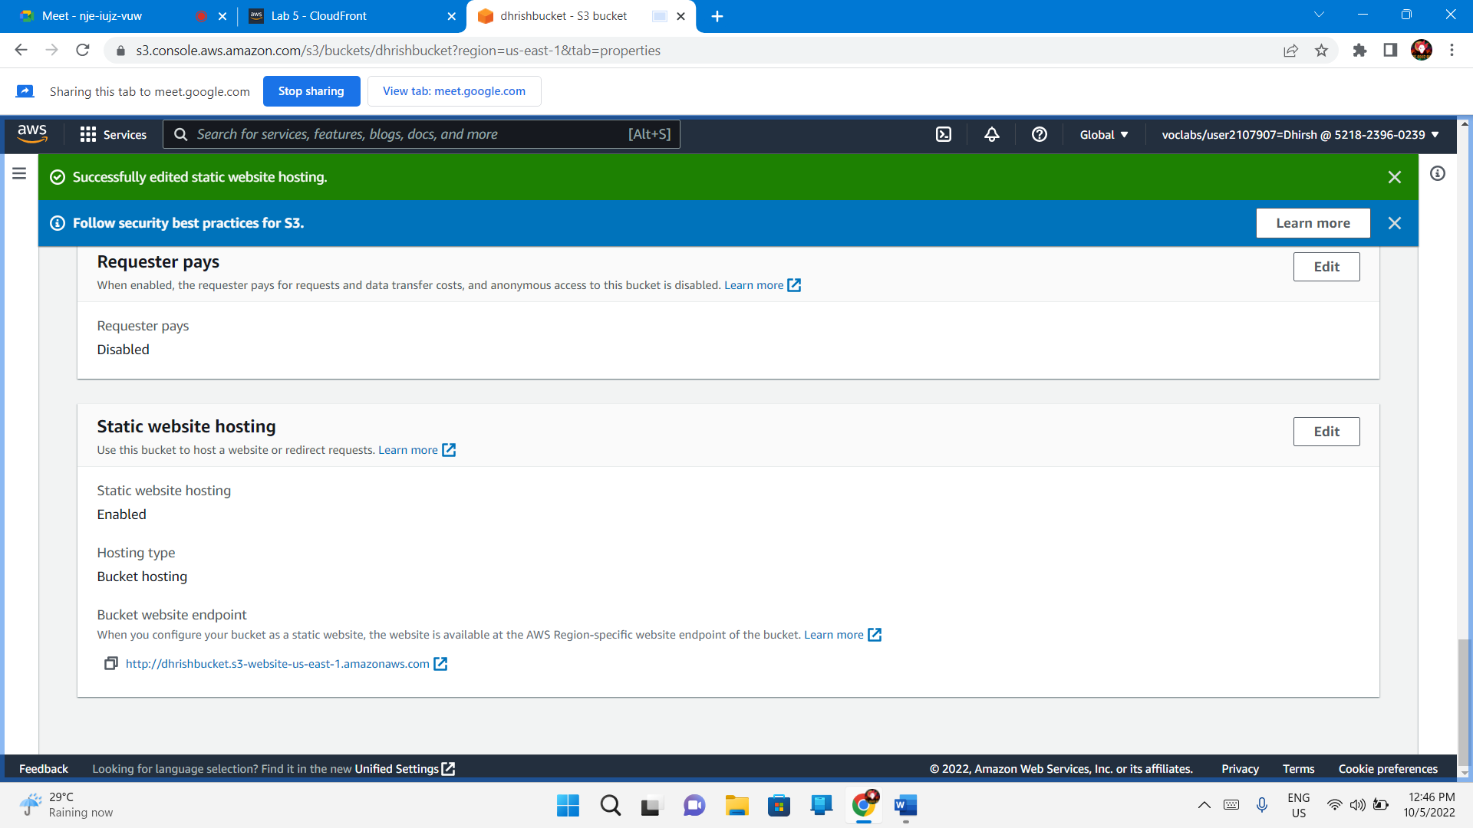

<http://dhrishbucket.s3-website-us-east-1.amazonaws.com>

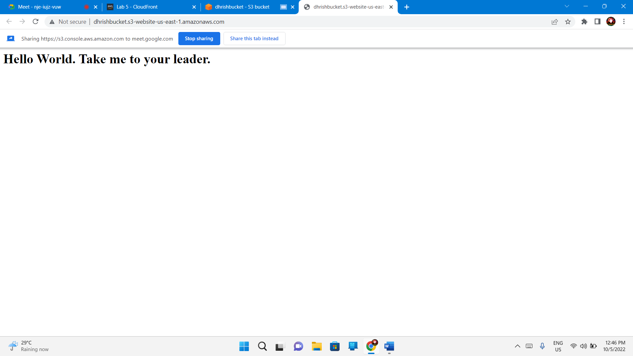

## Task 5. Create a CloudFront distribution to serve your website

**Services** menu -**Networking & Content Delivery** section, and choose **CloudFront**.

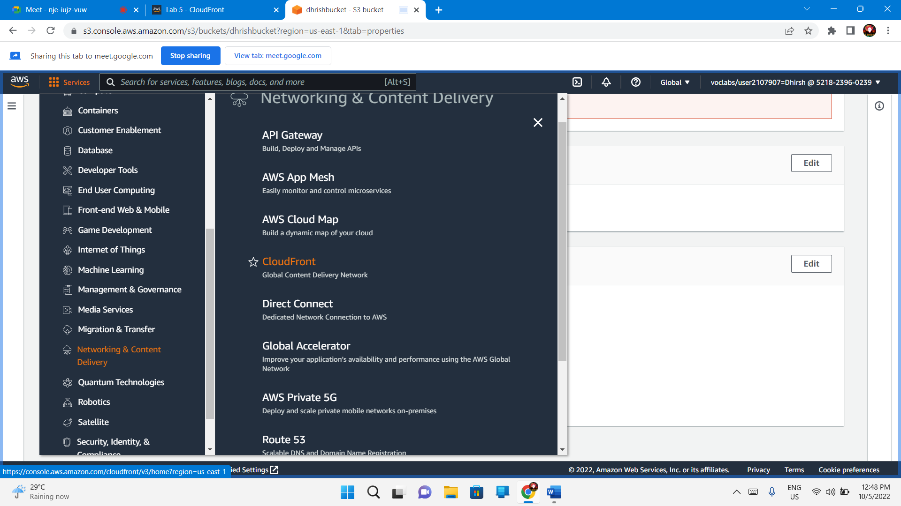

Create Cloud Front

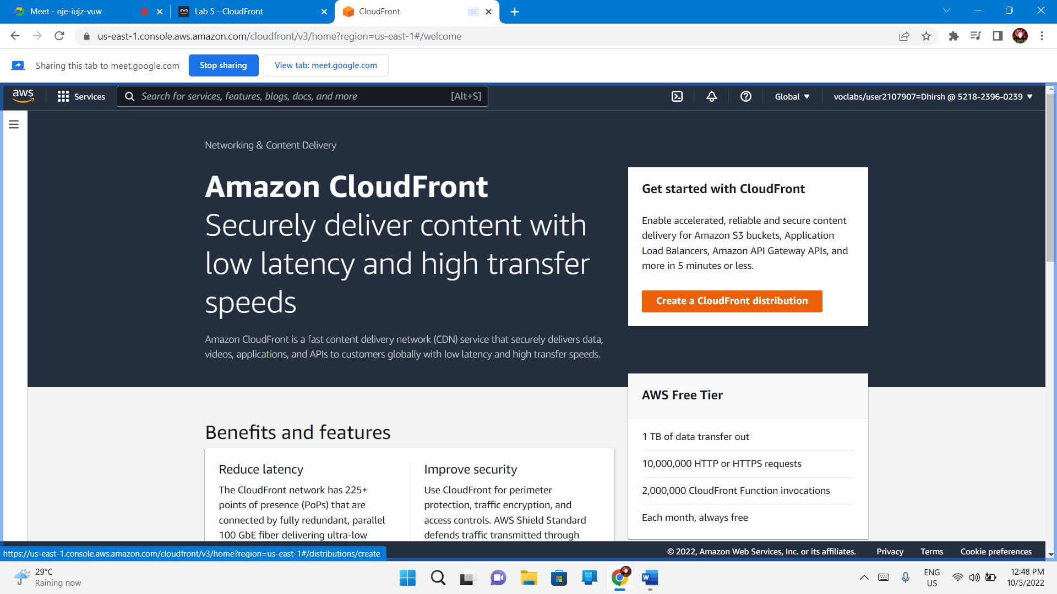

Choose origin domain as dhrishbucket – name is default

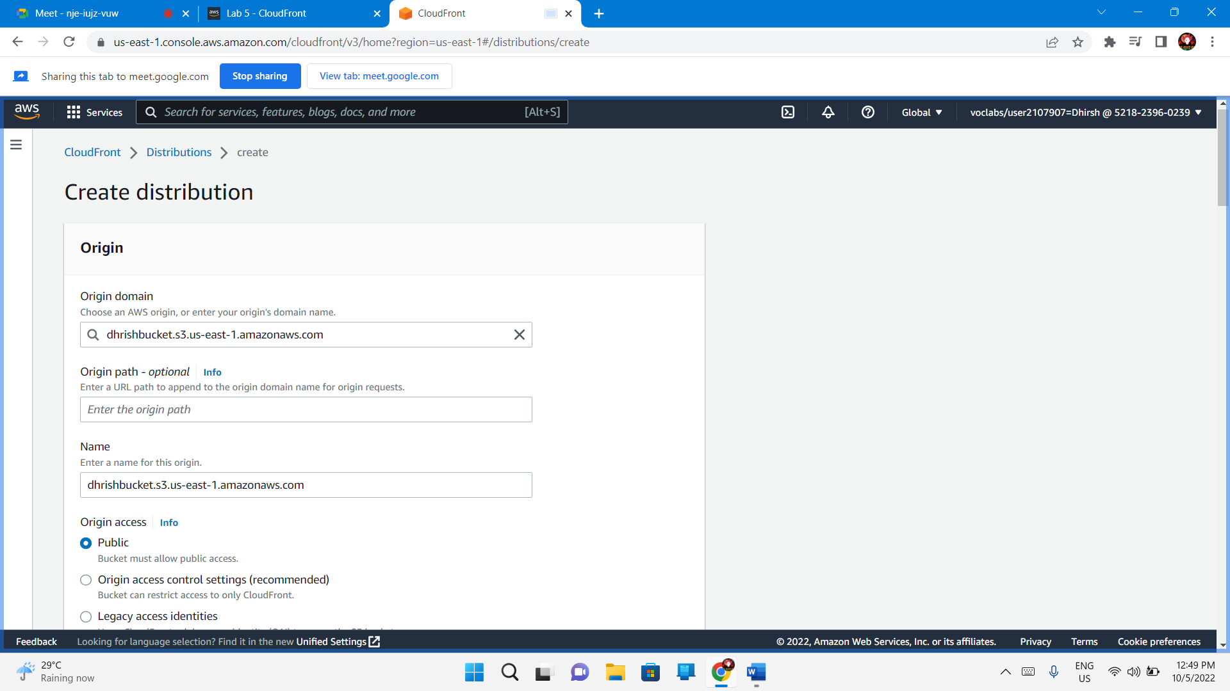

View protocol policy - Http and https

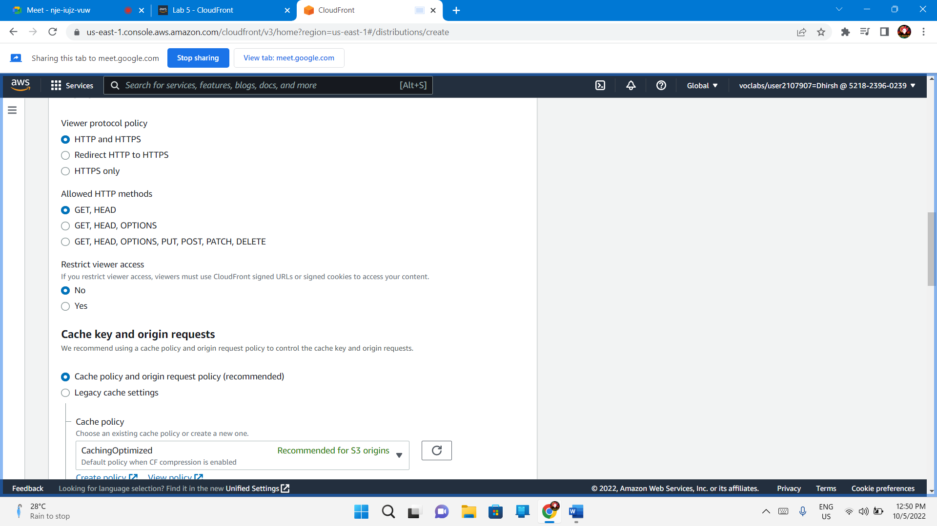

Create distribution

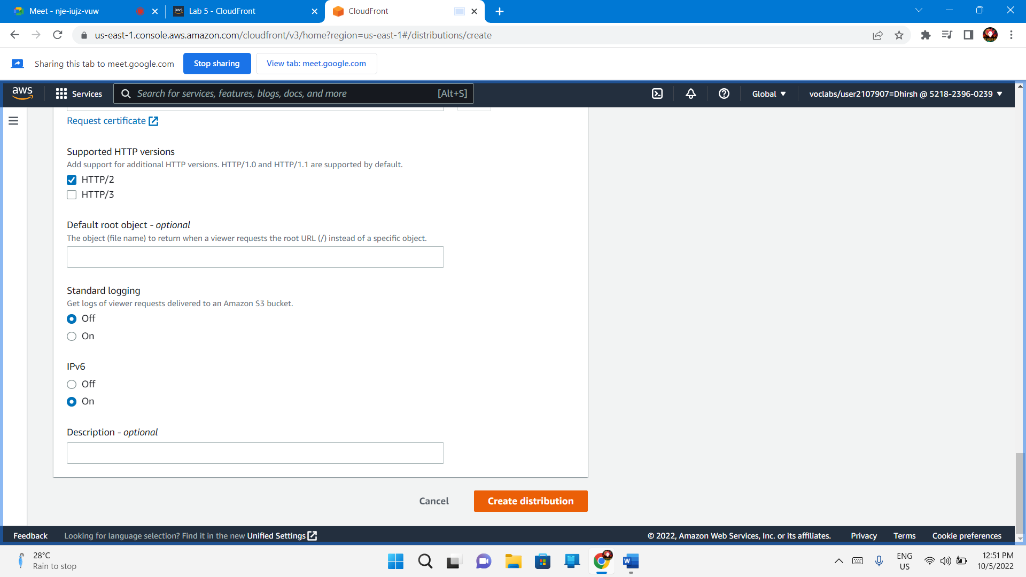

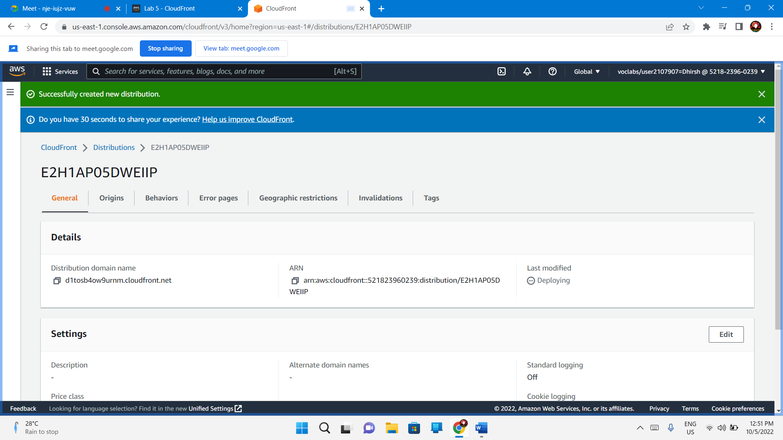

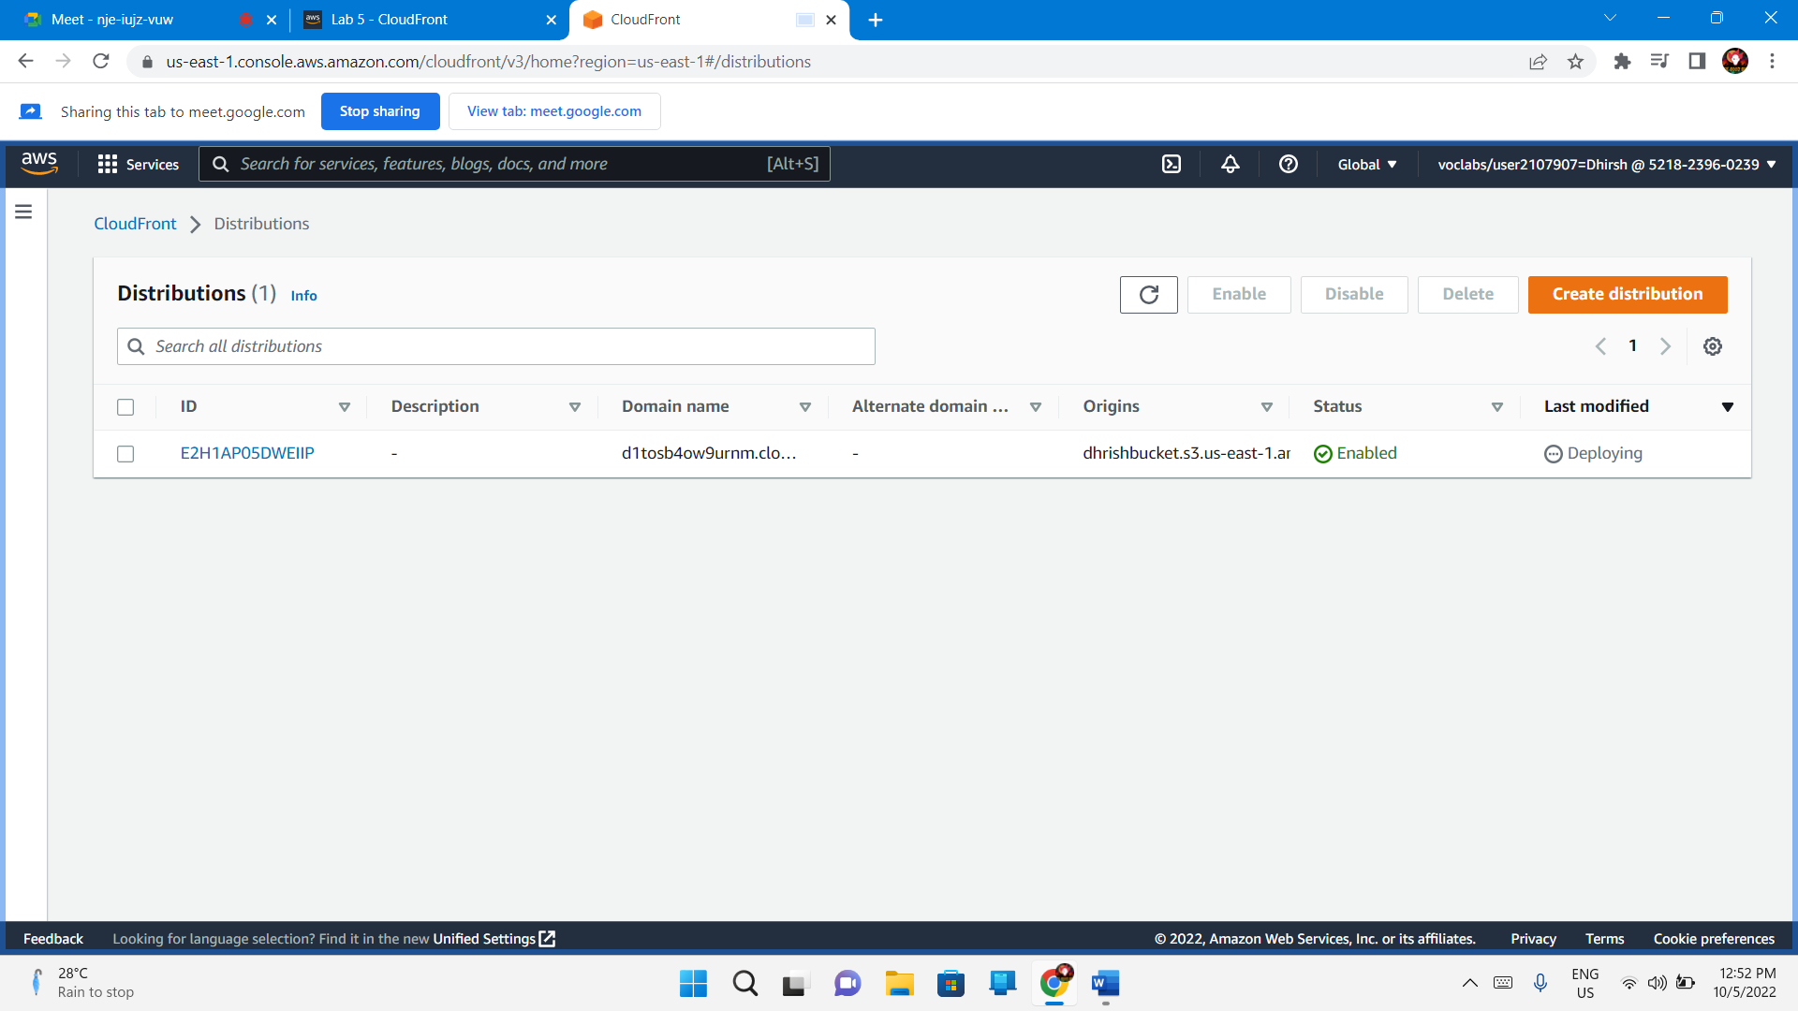

* Copy the **Domain Name** value

d1tosb4ow9urnm.cloudfront.net

* Create a html file
* <html>
* <head>My CloudFront Test</head>
* <body>
* <p>My test content goes here.</p>
* <p><img src="http://d1tosb4ow9urnm.cloudfront.net/object-name" alt="my test image">
* </body>
* </html>

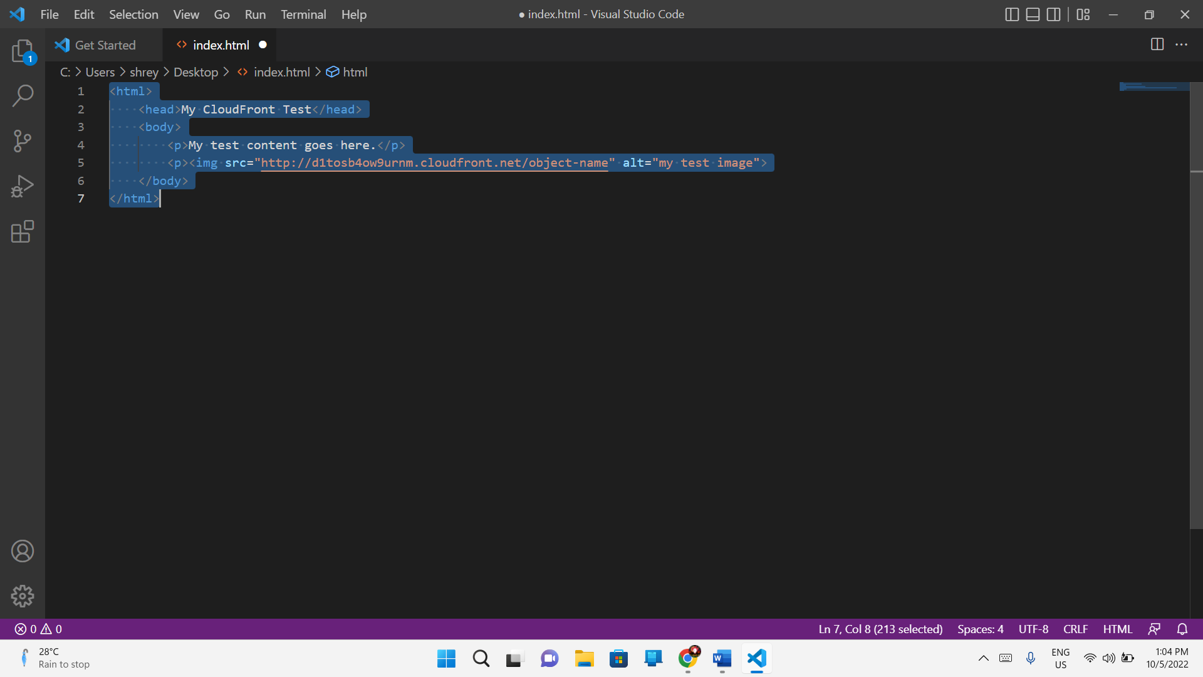

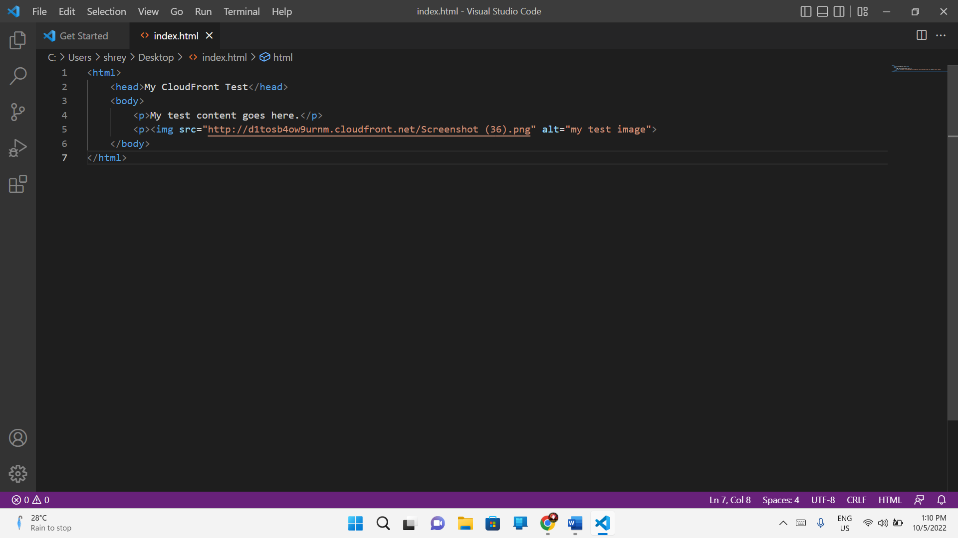

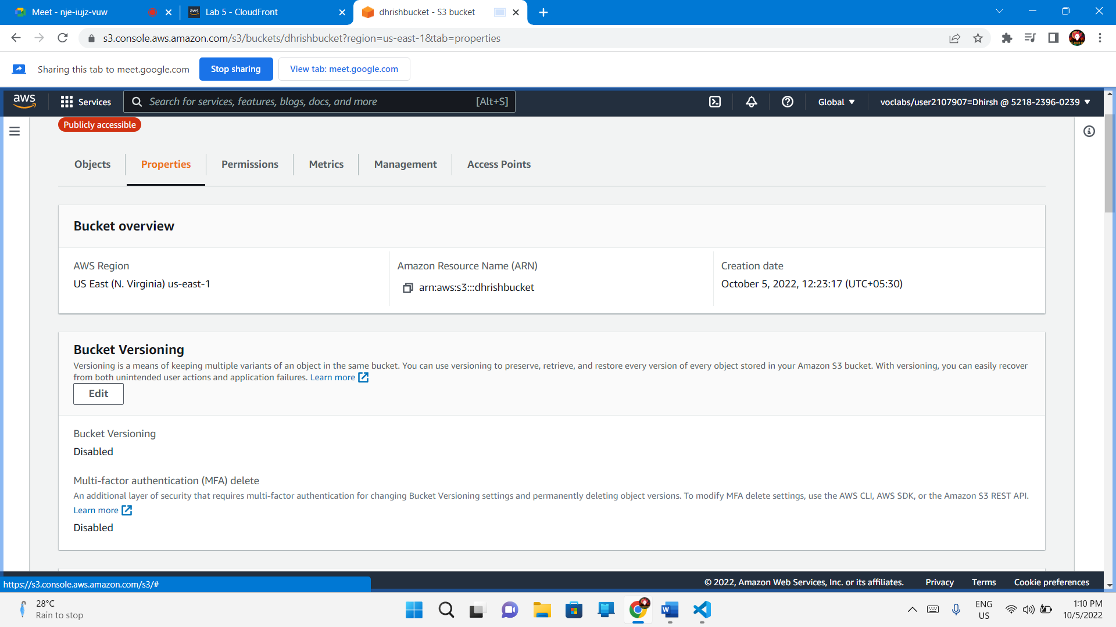

Upload the image Accordingly ( similar to index.html )

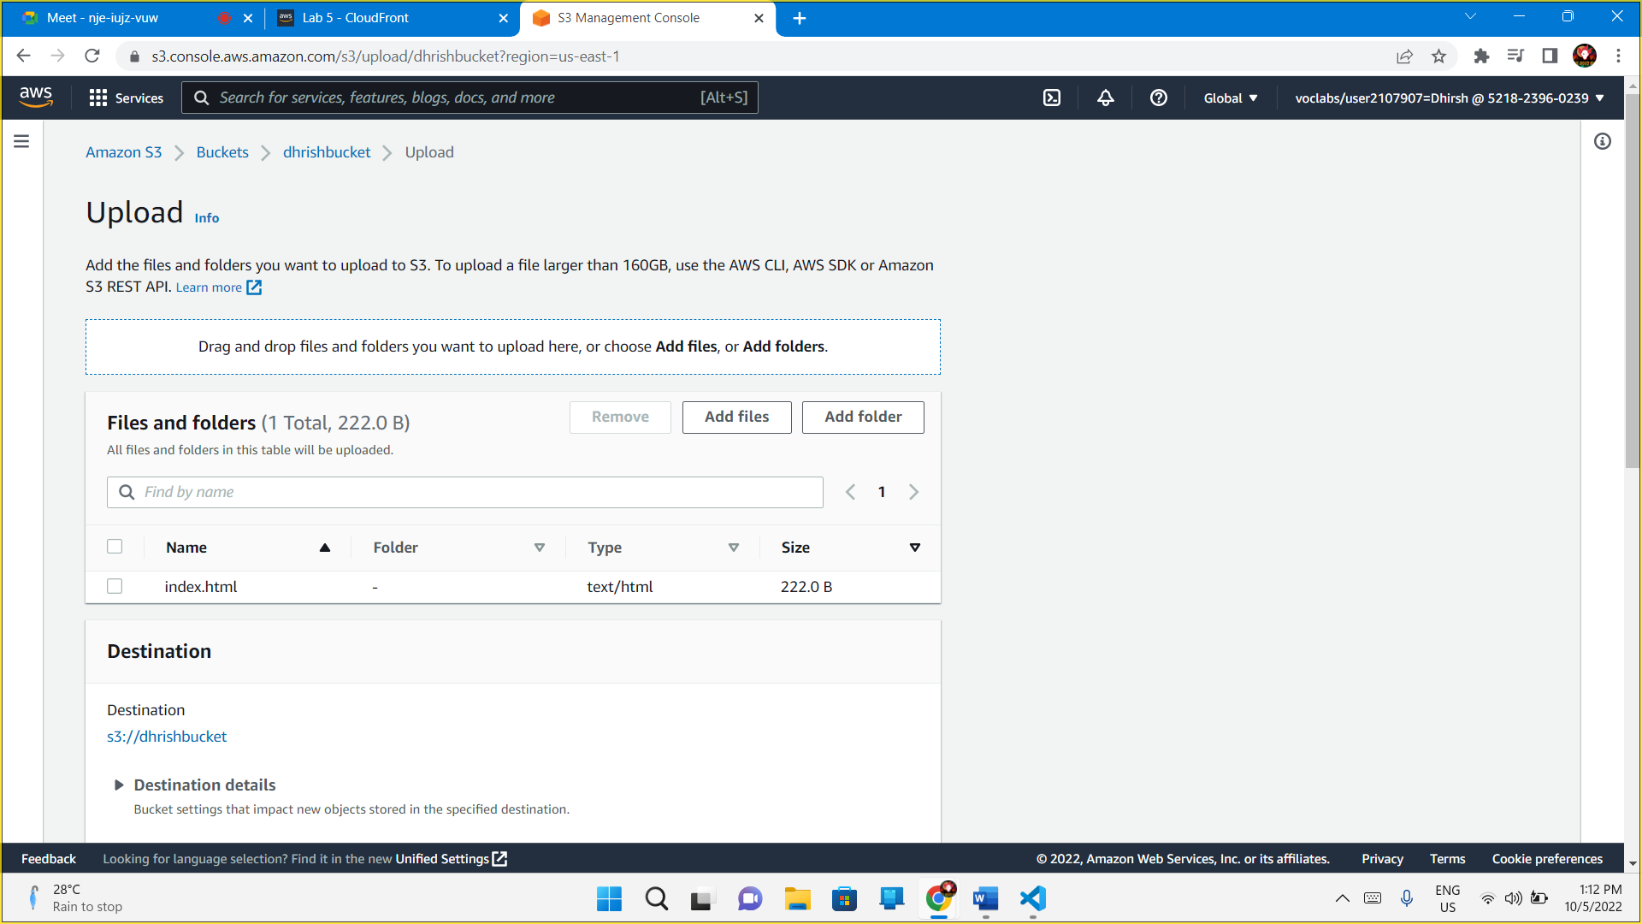

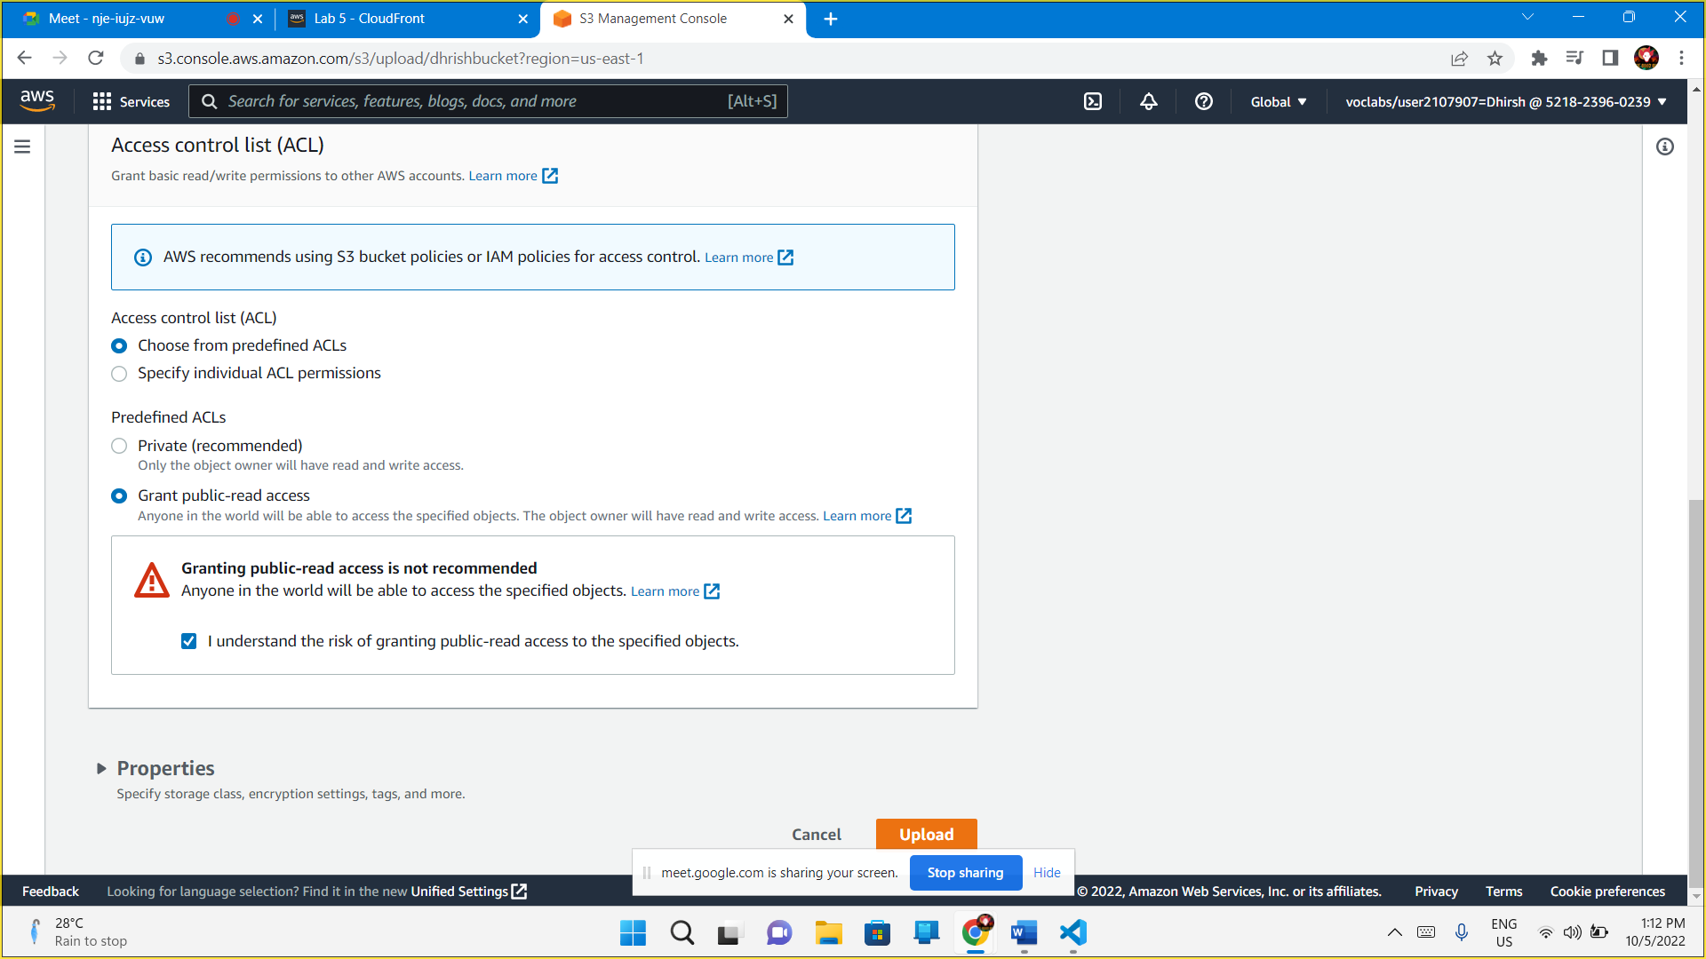

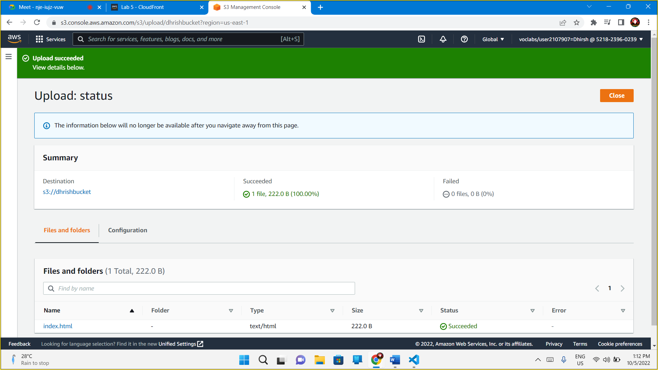

[http://dhrishbucket.s3-website-us-east-1.amazonaws.com](http://dhrishbucket.s3-website-us-east-1.amazonaws.com/)

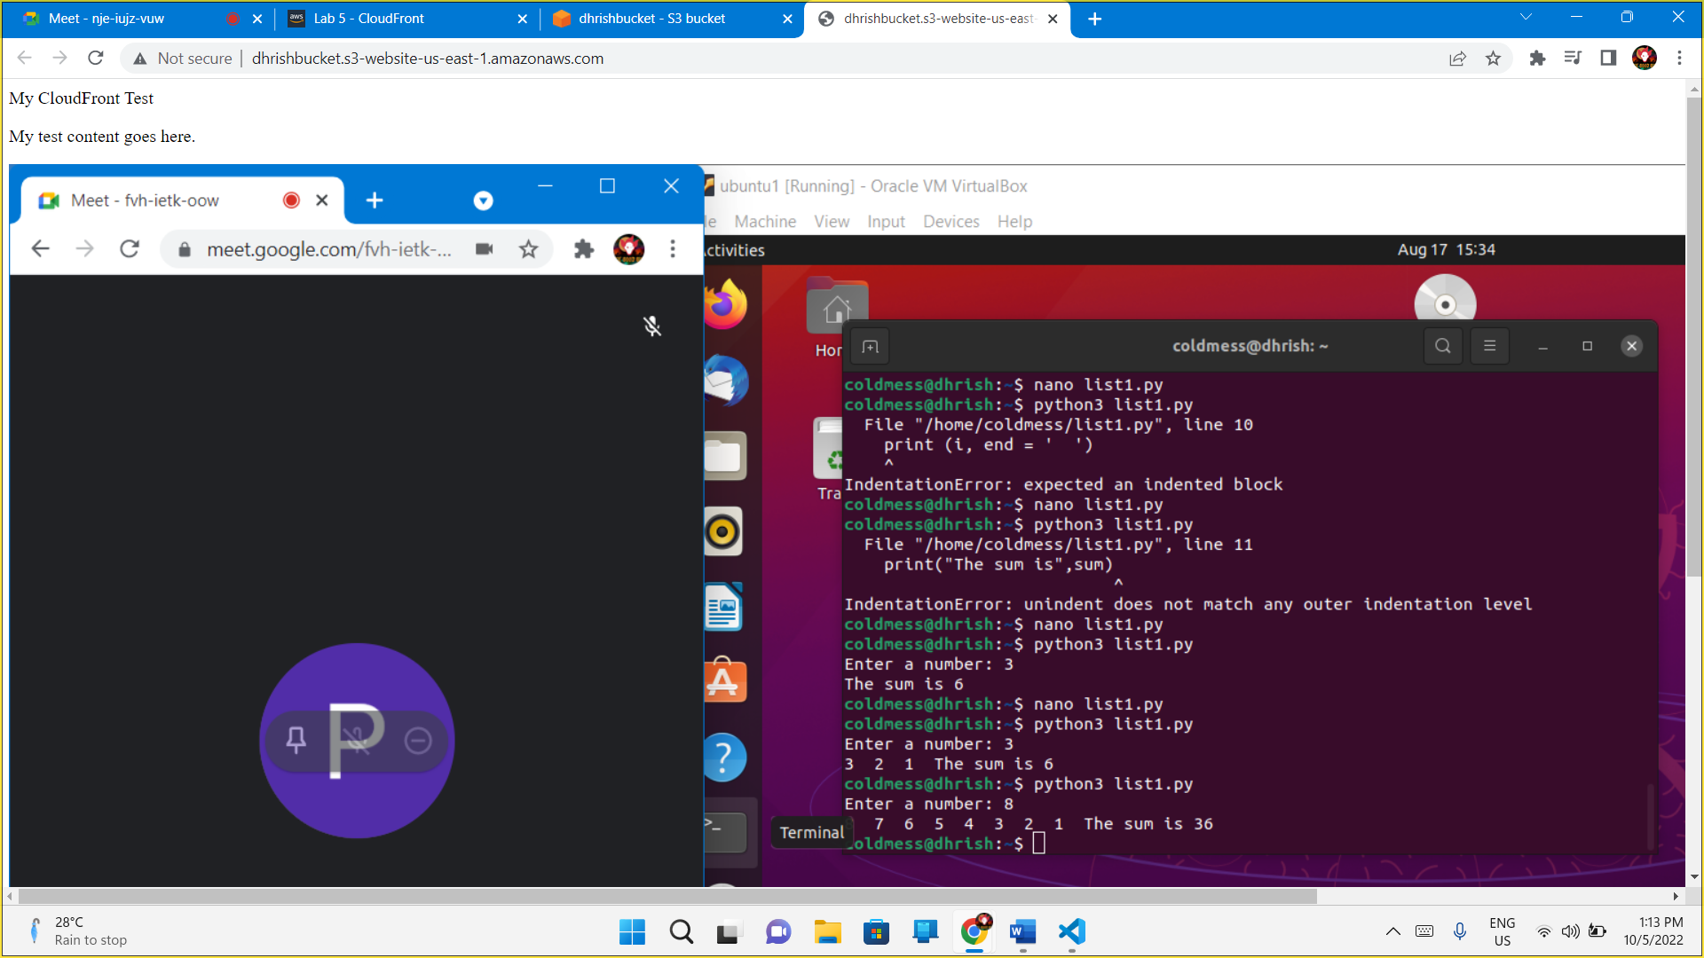

End Lab

